*Slumdog Millionaire*

Workbook

**Contents**

Foreword and Acknowledgements 4

Introductory Questions (before you read) - 5  
After You Read - Present Simple Tense 6

Reading practice 6

Writing practice 10

Past Simple Tense 11

Reading practice 12

Writing practice 13

Past continuous 14

Reading practice 15

Writing practice 17

2nd Conditional Tense 18

Gap fill exercise 19

Reading practice 20

Writing Practice 21

Vocabulary 22

Crossword 24

Wordsearch 25

Money - Test yourself 26

Think about it 28

Writing Practice 28

Exploratory Questions 29

Answer Key 30

**Foreword**

This workbook aims to supports adults to improve their English language skills. It covers reading, writing, grammar and comprehension. Each activity has an icon at the top to let you know what is being covered.

**Writing Reading Grammar Comprehension**



*Slumdog Millionaire* is based on the original novel Q & A written by Vikas Swarup. This workbook accompanies an adaptation of the original novel retold by Helen Holwill and illustrated by Matt Rota. This adaptation was written especially for people who are learning English as an additional language.

The adaptation is a Penguin Level 6 Reader which is B1+ in the CEFR framework. Sets of the book are available at Donegal County Library branches. We invite groups to set up book clubs and use this workbook to further develop their literacy skills*.* **Acknowledgements**

This workbook was written by Emer Tynan, and edited by Joseph Kelly, Donegal County Library Service and Adele McElhinney, Donegal ETB.

The Adult Literacy for Life National Programme Office, based in SOLAS, funded this project.  
Introductory Questions (before you read)



1. There is a movie based on this book, Slumdog Millionaire. Have you watched it? What do you know about the story?

Click or tap here to enter text.

1. Write three things you think might happen in this story.

Click or tap here to enter text.

1. A diagram of a mind map

   AI-generated content may be incorrect.A theme of a story is an important message in the story.   
   What do you think the themes of this story might be?   
   Fill in the mind map below with your ideas.

Click or tap here to enter text.

Click or tap here to enter text.

Click or tap here to enter text.

Click or tap here to enter text.

1. A large part of this story **is set** in India. This means that it happens in India. Have you ever visited India? If not, would you like to?   
   Why/Why not?

Click or tap here to enter text.

After You Read - Present Simple Tense



**Verb: To Be Verb: To Work**

|  |  |
| --- | --- |
| **Subject** | **Conjugation** |
| I | am |
| You | are |
| He/She/It | is |
| We | are |
| You (plural) | are |
| They | are |

|  |  |
| --- | --- |
| **Subject** | **Conjugation** |
| I | work |
| You | work |
| He/She/It | works |
| We | work |
| You (plural) | work |
| They | work |

Note

For **regular verbs** like "to work," we add **-s** or **-es** only for the **third person singular** (he/she/it).

We use the Present Simple for the following situations:

1. To talk about routines.

Example: I get up every day at 6am.

2. To talk about permanent situations.

Example: I live in Barcelona.

3. To talk about future scheduled events (according to a timetable). Example: The bus leaves at 10.40am.

4. To talk about general truths and facts.

Example: Water boils at 100 degrees celsius.

1. To talk about general abilities.

Example: I play the piano

1. To talk about feelings

Example: I feel happy today

Example Sentence Practice



Try to write your own example sentences for each of the rules above.

To talk about routines.

Click or tap here to enter text.

To talk about permanent situations.

Click or tap here to enter text.

To talk about future scheduled events (according to a timetable).

Click or tap here to enter text.

To talk about general truths and facts.

Click or tap here to enter text.

To talk about general abilities.

Click or tap here to enter text.

To talk about feelings.

Click or tap here to enter text.

Reading practice



Read the following text and find an example of each rule in the text.

India is a country that fascinates many people from around the world. Every year, it welcomes millions of visitors who come to explore its rich culture and history. Many people in India celebrate traditional festivals, like Diwali and Holi, which happen at specific times each year. These festivals bring families together, and they fill cities with light and colour.

One unique part of life in India is the routine of drinking chai. Locals drink this tea every day, and many say it’s essential for a good start in the morning. Chai stalls line the streets, and friends often meet here to relax and talk. India also has a warm climate in most parts of the country, making it possible to grow a variety of fruits and spices.

People often visit India’s famous landmarks, like the Taj Mahal, which stands as a permanent symbol of love and beauty. Tourists can usually see the Taj Mahal at sunrise, as guided tours begin early in the morning according to a set timetable.

India sits on the Asian continent and holds a rich history. Elephants and tigers live in its forests, and they are part of India’s wildlife heritage. India grows spices, such as turmeric and cardamom, which are used in cooking worldwide.

Indian people have a unique talent for cooking delicious food, and their skills impress visitors from all over. I love Indian food because it’s full of flavours and spices that taste incredible.



To talk about routines.

Click or tap here to enter text.

To talk about permanent situations.

Click or tap here to enter text.

To talk about future scheduled events (according to a timetable).

Click or tap here to enter text.

To talk about general truths and facts.

Click or tap here to enter text.

To talk about general abilities.

Click or tap here to enter text.

To talk about feelings.

Click or tap here to enter text.

Writing practice



Imagine you are Ram. Write a letter to Nita describing your working day in Jimmy’s restaurant.

Click or tap here to enter text.

Past Simple Tense



Verb: To be (irregular verb) Verb: To work (regular verb)

|  |  |  |  |  |  |  |  |  |  |  |  |  |  |  |  |
| --- | --- | --- | --- | --- | --- | --- | --- | --- | --- | --- | --- | --- | --- | --- | --- |
| |  |  | | --- | --- | | **Subject** | **Conjugation** | | I | was | | You | were | | He/She/It | was | | We | were | | You (plural) | were | | They | were | |  |

|  |  |
| --- | --- |
| **Subject** | **Conjugation** |
| I | worked |
| You | worked |
| He/She/It | worked |
| We | worked |
| You (plural) | worked |
| They | worked |

Note

**Regular** verbs like "**to work"** form the past simple by adding **-ed** to the base form. Several verbs form their past tense in an irregular way.

We use the past simple to:

1. Talk about single completed actions in the past.

Example: I washed the dishes after dinner.

2. Talk about repeated actions in the past that don’t happen now.

Example: My father walked to school every day when he young.

3. Past states.

Example: I knew her when we were in school.

Example Sentence Practice

Write your own example sentences for each of the rules above.

Talk about single completed actions in the past.

Click or tap here to enter text.

Talk about repeated actions in the past that don’t happen now.

Click or tap here to enter text.

Past states.

Click or tap here to enter text.

Reading practice



Read the following text and find an example of each rule in the text.

When I visited India last year, I saw the Taj Mahal for the first time. It stood there in its full beauty, just as it has for centuries. Long ago, people travelled from distant lands just to marvel at this monument, and I finally understood why. During my stay, I explored several markets where people once bought and sold spices and goods daily, creating a lively atmosphere that you don’t often find in the same way today.

Back in the 16th century, the Mughal Empire ruled much of India, and many of its impressive structures still exist today. In the past, many families lived in small villages, and they gathered regularly for festivals and celebrations, which would bring everyone together. Although life has changed in many parts of India now, those historical places and traditions left a mark on the country’s culture.

Talk about single completed actions in the past.

Click or tap here to enter text.

Talk about repeated actions in the past that don’t happen now.

Click or tap here to enter text.

Past states.

Click or tap here to enter text. Writing practice



You are Ram. It is the morning after you won the quiz show.

Write about what happened after you won, how you felt and how you celebrated.

Click or tap here to enter text.

Past Continuous Tense



We use the past continuous to talk about :

1. Actions in progress at a point in the past.

Example: I was walking my dog at 7am this morning.

2. Temporary situations in the past.

Example: I was staying in a friend’s house until my apartment was ready.

3. Annoying past habits (usually used with always).

Example: My sister was always borrowing my clothes without asking when we were teenagers.

4. Arrangements and plans for the future in the past.

Example: I was excited because I was meeting my sister for lunch later that day.

We also use the past continuous to talk about:

5. Actions in progress over a period of time

Example: I was walking my dog all morning.

6. Two actions in progress at the same time

Example: I was talking to my sister on the phone while I was walking my dog.

1. Background information in a story

Example: The sun was shining and birds were singing. Suddenly, I heard a big crash!

The past simple and the past continuous are often used together to show that one action happened (past simple) to interrupt another action (past continuous).

Example: I was washing the dishes when the phone rang.

Reading practice



Read the following text and find an example of each rule in the text.

Last Saturday night, Emma was participating in a live quiz show on TV. She was hoping to win the grand prize, a new car, which would be her first. While she was answering questions, the audience was cheering loudly, adding to the excitement and pressure. Her best friend was always texting her good luck messages during each commercial break, which could be a bit distracting!

Emma and her team were planning to celebrate after the show if they won, as they were dreaming of a big victory for weeks. Throughout the quiz, she noticed that some contestants were getting nervous while others were laughing to stay calm. The host, who was wearing a bright blue suit, kept giving little hints, which helped Emma focus.

In the end, as the timer was ticking down and Emma was thinking carefully about the final question, the whole studio was holding its breath. Although she didn’t win, she had an incredible time and was already planning to join again next season.



Actions in progress at a point in the past.

Click or tap here to enter text.

Temporary situations in the past.

Click or tap here to enter text.

Annoying past habits (usually used with always).

Click or tap here to enter text.

Arrangements and plans for the future in the past.

Click or tap here to enter text.

Actions in progress over a period of time.

Click or tap here to enter text.

Two actions in progress at the same time.

Click or tap here to enter text.

Background information in a story.

Click or tap here to enter text.

Writing practice



Describe the moment Ram and Nita were reunited.

Where were they?

How did they feel when they saw each other again?

What was happening around them?

Use at least 3 examples of the past continuous and past simple.

Click or tap here to enter text.

2nd Conditional Tense



We use the 2nd Conditional to talk about imaginary or hypothetical situations.

To form this tense we use:

**If + past simple, would + infinitive**

Example: If I won the lottery, I would travel the world

If I saw a ghost, I would scream.

We can also use other modal verbs such as could or might, instead of would.

Example: If I won the lottery, I could leave my job.

I might run away if I saw a ghost.

Gap fill exercise



Complete the exercise below with the correct form of the verb in brackets.

1. If I _______ (have) more free time, I would _______ (travel) around the world.
2. If she _______ (know) how to cook, she would _______ (invite) us for dinner.
3. If they _______ (live) closer, we would _______ (see) each other more often.
4. If it _______ (not rain) so much, we would _______ (go) to the beach.
5. If I _______ (be) you, I would _______ (talk) to the teacher about it.
6. If he _______ (study) harder, he would _______ (pass) the exam.
7. If we _______ (win) the lottery, we would _______ (buy) a new house.
8. If she _______ (speak) Spanish fluently, she would _______ (move) to Spain.
9. If I _______ (find) a good book, I would _______ (read) it all night.
10. If they _______ (have) a car, they would _______ (drive) to work every day.

Reading practice



Read the following text and find 4 examples of the 2nd conditional tense.

If I won a lot of money, I would throw a big party to celebrate. I would invite all my friends and family, and we would have delicious food, music, and lots of fun. The party would be at a beautiful venue, like a beach or a fancy hotel.

After the celebration, I would think carefully about how to spend the money. If I had enough, I would buy a nice house with a garden where my family could live comfortably. I would also travel to some amazing places, like Japan or New Zealand, because I have always wanted to see their beautiful landscapes and cultures.

I wouldn’t spend all the money on myself, though. If I had a lot left, I would donate some to charity to help people in need. Maybe I would even start my own project to support education or the environment.

Winning a lot of money would be exciting, but I know it’s important to use it wisely. If I planned well, the money could make a big difference in my life and in the lives of others.

1. Click or tap here to enter text.
2. Click or tap here to enter text.
3. Click or tap here to enter text.
4. Click or tap here to enter text.

Writing Practice



If you won a million euro on a quiz show like Ram , what would you do?

Click or tap here to enter text.

Vocabulary



The characters

1. Who is your favourite character in the story? Why?

Click or tap here to enter text.

1. An adjective is a describing word. It gives more information about a noun.

Example: There is a **big** car outside.

Big is the adjective. It describes the car.

Some examples of adjectives of personality are:   
friendly, happy, brave and kind.

Use 3 adjectives of personality to describe each of the characters below:

Ram Click or tap here to enter text.

Salim Click or tap here to enter text.

Nita Click or tap here to enter text.

Smita Click or tap here to enter text.

Prem Kumar Click or tap here to enter text.

Neelima Click or tap here to enter text.



1. Imagine you are the writer, Vihas Swarup. You are going to change one important thing about Ram, Salim, Nita and Smita.

How would these changes affect the story?

Click or tap here to enter text.

1. How did you feel about Ram at the beginning of the story?

How did you feel about him at the end?

Click or tap here to enter text.

Crossword



Print this page to complete the crossword below using the clues given. Or you can play this [crossword online.](https://worksheets.theteacherscorner.net/make-your-own/crossword/play-crossword.php?data=eNpNUcuK3DAQ_JW-5WIWy8-1dNxTDgtLJuRo0NqaGW1kyUhyzIA_PtVmCLlUtburu0pYNIVojovbljnc6N06Z4PXNpqjLBoZlSjEiZXcgLVcgY00wPbETiZVofNH1cAAHNCpC1FKzSSkY6qkZarlohroHHBA3Z6bLWqruqKUE1DgSgc_D6xlBrJfB78E7M5Oj-Nd8XpqBnR67BogJ-4x3YADNK_oO2AvZzWc9YDaKlHCZmWq-HUljAJTAx2o5ceW8JqYen5oCTcoBb68EhUIsxp7O1MDL1DLp-szI-jcq8-9Q4_V-LbFaPz0oHCl7362WumxHn_o5VuiT5MyXaM1fn5BuxkvYTHBG9rvgaawrCabRNaTfn7ZjP_E0u5_aTL0FT7JZrKJcqAQb9pbdDX9_EXpHvaCrtYtGNDq9IMP9M8IWFTzKMbLop2j24br8798Tu8PE9FonvMYwsJ5vrR1cDbREJS060S_zZppjTYhVOQj7fhhwuqQUOfpbv0NcTgLp5iCn0zML-rwkB9_ATsGwqQ%3D)

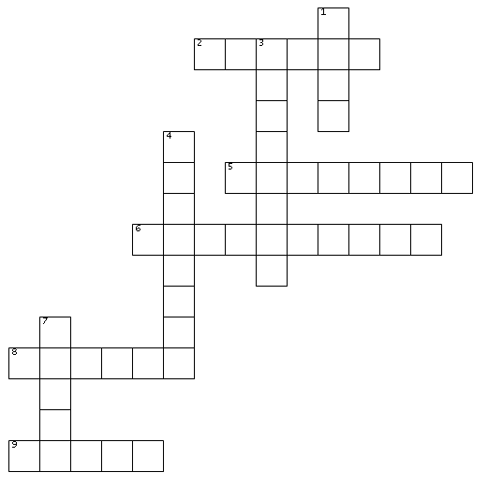

Across  
2. Currency of India  
5. People watching a show or concert  
6. Someone who competes in a competition  
8. Ram's job  
9. Ram's lawyer  
  
Down  
1. Small room in jail where Ram was kept prisoner  
3. Someone whose job it is to organise a TV show, film or play  
4. Small gun  
7. Ram's best friend

Wordsearch



Print this page and find all the hidden words associated with the story in the wordsearch below. Or you can complete this [wordsearch online.](https://thewordsearch.com/puzzle/8128556/slumdog-millionaire/)

orphanage mumbai hindi

taj mahal rupees slum

billion waiter neelima quiz

|  |  |  |  |  |  |  |  |  |  |  |  |  |  |  |  |  |  |
| --- | --- | --- | --- | --- | --- | --- | --- | --- | --- | --- | --- | --- | --- | --- | --- | --- | --- |
| l | w | x | e | d | d | a | t | s | l | u | m | e | j | i | l | t | w |
| I | s | x | s | z | r | j | t | m | q | b | b | v | s | c | f | f | q |
| x | n | q | j | z | u | u | o | t | u | j | i | h | z | z | t | q | l |
| w | e | w | u | m | p | t | r | w | a | r | m | l | r | w | t | u | c |
| w | e | b | s | u | e | j | p | f | o | j | d | o | l | o | u | w | w |
| v | l | r | e | m | e | t | h | l | q | k | m | e | w | i | u | p | a |
| z | i | s | m | b | s | t | a | h | u | b | w | a | r | a | o | u | i |
| u | m | n | u | a | y | b | n | r | i | p | e | h | h | l | w | n | t |
| w | a | w | u | i | q | l | a | b | z | n | v | e | z | a | y | b | e |
| g | b | k | g | m | f | h | g | o | l | x | d | h | w | r | l | i | r |
| h | k | e | s | b | q | r | e | m | q | s | w | i | q | t | c | q | q |
| q | n | s | v | q | d | y | y | m | c | d | j | m | g | j | q | k | p |



Money - Test yourself

Complete the mind map below with words related to money.

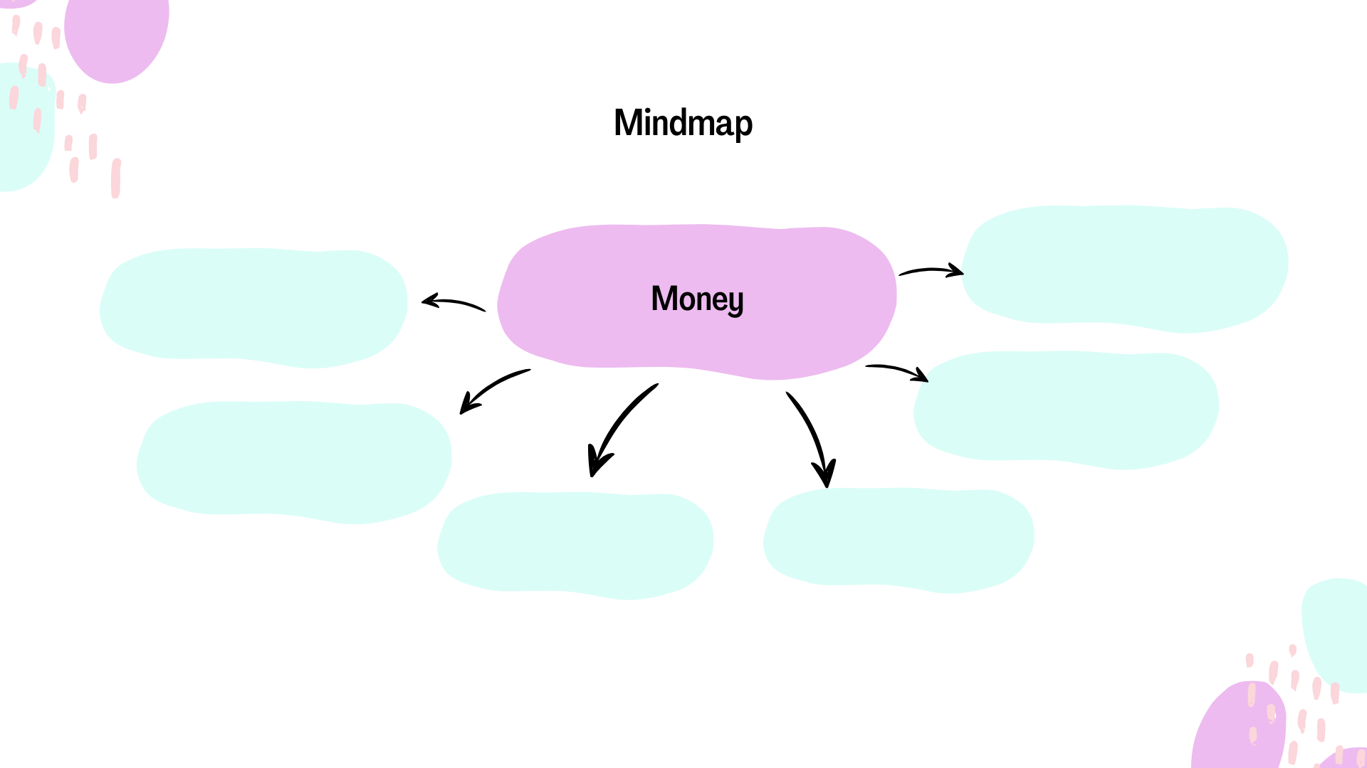

Click or tap here to enter text.

Click or tap here to enter text.

Click or tap here to enter text.

Click or tap here to enter text.

Click or tap here to enter text.

Click or tap here to enter text.

Choose the correct word from the box to complete   
each sentence. Each word can be used only once.



earn save spend borrow owe

lend pay invest waste afford

1. I need to ________ more money if I want to go on vacation next year.
2. My friend asked me to ________ him $20 until he gets his next pay check.
3. It’s important to ________ some money each month for emergencies.
4. They had to ________ a lot on the wedding, so now they’re trying to save.
5. I don’t want to ________ any more money on things I don’t need.
6. She’s trying to ________ her money wisely by putting it into a savings account.
7. Can you ________ me back the €15 you borrowed last week?
8. If you don’t ________ off your credit card debt, the interest will keep adding up.
9. He didn’t ________ that much from his first job, but it was good experience.
10. I can’t ________ to buy a new car right now, so I’m sticking with my old one.



Think about it

There is a saying in English: ”money is the root of all evil”.

What does this mean? Do you agree with this? Why/Why not?



Writing Practice

Ram’s life has been difficult so far. He has had many obstacles to overcome and he seems to remain a very positive person.

How do you think his money will change his life? Do you think the money will change him as a person?

Click or tap here to enter text.

Exploratory Questions



1. Ram has a special coin with heads on both sides.   
   He called it his lucky coin. Why?
2. Do you believe in luck? Why/why not?
3. What is considered to be lucky in your culture?
4. Do you think luck helped Ram win the money?
5. Ram’s *street smarts* help him a lot throughout this book. What are street smarts?
6. What do you think Ram’s life will be like in the future?
7. There are some famous stories from around the world about cheating on quiz shows. Research this topic and write about 1 famous story that you find.
8. If you were to change a part of this story, what would it be?

Answer Key

Grammar - Present Simple Text

Hidden examples of present simple in the text:

1. To talk about routines: "Locals drink this tea every day." "Friends often meet here to relax and talk."
2. To talk about permanent situations: "The Taj Mahal stands as a permanent symbol of love and beauty." "India sits on the Asian continent."
3. To talk about future scheduled events (according to a timetable): "Guided tours begin early in the morning."
4. To talk about general truths and facts: "India welcomes millions of visitors." "India has a warm climate in most parts of the country."
5. To talk about general abilities: "Indian people have a unique talent for cooking delicious food."
6. To talk about feelings: "I love Indian food because it’s full of flavours."

Past Simple Text

Hidden examples of past simple in the text:

1. Single Completed Actions in the Past: "When I visited India last year, I saw the Taj Mahal for the first time." "During my stay, I explored several markets..."
2. Repeated Actions in the Past That Don’t Happen Now: "Long ago, people travelled from distant lands just to marvel at this monument..." "...people once bought and sold spices and goods daily, creating a lively atmosphere that you don’t often find in the same way today."
3. Past States: "In the past, many families lived in small villages, and they gathered regularly for festivals and celebrations..." "Back in the 16th century, the Mughal Empire ruled much of India."

Past Continuous Text

Hidden examples of past continuous in the text:

1. Actions in progress at a point in the past: "Emma was participating in a live quiz show on TV."
2. Temporary situations in the past: "She was hoping to win the grand prize, a new car, which would be her first."
3. Annoying past habits (usually used with ‘always’): "Her best friend was always texting her good luck messages during each commercial break, which could be a bit distracting!"
4. Arrangements and plans for the future in the past: "Emma and her team were planning to celebrate after the show if they won."
5. Actions in progress over a period of time: "Throughout the quiz, she noticed that some contestants were getting nervous while others were laughing to stay calm."
6. Two actions in progress at the same time: "As the timer was ticking down and Emma was thinking carefully about the final question, the whole studio was holding its breath."
7. Background information in a story: "The host, who was wearing a bright blue suit, kept giving little hints, which helped Emma focus."

2nd Conditional Gap Fill

1. Had / would travel
2. Knew / would invite
3. Lived / would see
4. Didn't rain / would go
5. Were / would talk
6. Studied / would pass
7. Won / would buy
8. Spoke / would move
9. Found / would read
10. Had / would drive

2nd Conditional Text

Hidden examples of 2nd Conditional in the text:

1. If I won a lot of money, I would throw a big party to celebrate.
2. If I had enough, I would buy a nice house with a garden where my family could live comfortably.
3. If I had a lot left, I would donate some to charity to help people in need.
4. If I planned well, the money could make a big difference in my life and in the lives of others.

Crossword

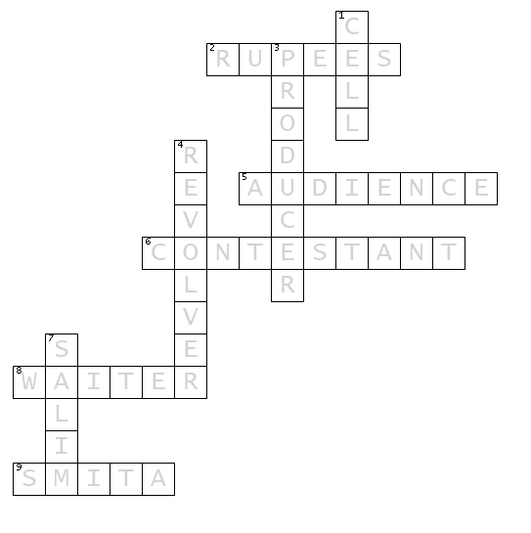

Wordsearch

|  |  |  |  |  |  |  |  |  |  |  |  |  |  |  |  |  |  |
| --- | --- | --- | --- | --- | --- | --- | --- | --- | --- | --- | --- | --- | --- | --- | --- | --- | --- |
| l | w | x | e | d | d | a | t | s | l | u | m | e | j | i | l | t | w |
| I | s | x | s | z | r | j | t | m | q | b | b | v | s | c | f | f | q |
| x | n | q | j | z | u | u | o | t | u | j | i | h | z | z | t | q | l |
| w | e | w | u | m | p | t | r | w | a | r | m | l | r | w | t | u | c |
| w | e | b | s | u | e | j | p | f | o | j | d | o | l | o | u | w | w |
| v | l | r | e | m | e | t | h | l | q | k | m | e | w | i | u | p | a |
| z | i | s | m | b | s | t | a | h | u | b | w | a | r | a | o | u | i |
| u | m | n | u | a | y | b | n | r | i | p | e | h | h | l | w | n | t |
| w | a | w | u | i | q | l | a | b | z | n | v | e | z | a | y | b | e |
| g | b | k | g | m | f | h | g | o | l | x | d | h | w | r | l | i | r |
| h | k | e | s | b | q | r | e | m | q | s | w | i | q | t | c | q | q |
| q | n | s | v | q | d | y | y | m | c | d | j | m | g | j | q | k | p |

Money Collocations Exercise

1. I need to earn more money if I want to go on vacation next year.
2. My friend asked me to lend him $20 until he gets his next pay check.
3. It’s important to save some money each month for emergencies.
4. They had to spend a lot on the wedding, so now they’re trying to save.
5. I don’t want to waste any more money on things I don’t need.
6. She’s trying to invest her money wisely by putting it into a savings account.
7. Can you pay me back the $15 you borrowed last week?
8. If you don’t pay off your credit card debt, the interest will keep adding up.
9. He didn’t earn that much from his first job, but it was good experience.
10. I can’t afford to buy a new car right now, so I’m sticking with my old one.