*The Talented   
Mr Ripley*

Workbook

# Contents

Foreword and Acknowledgements 4

Introductory Questions (before you read) 5

After You Read - Present Simple Tense 6

Reading practice 8

Writing practice 11

Past Simple Tense 12

Reading practice 13

Writing practice 14

Past Continuous Tense 15

Reading practice 16

Writing practice 18

Reading practice 21

Writing practice 23

Vocabulary 24

Crossword 26

Wordsearch 27

Writing Practice 30

Exploratory Questions 31

Answer Key 32

# Foreword

This workbook aims to supports adults to improve their English language skills. It covers reading, writing, grammar and comprehension. Each activity has an icon at the top to let you know what is being covered.

**Writing Reading Grammar Comprehension**



# *The Talented Mr Ripley* was written by Patricia Highsmith. This workbook accompanies an adaptation of the original story retold by Anna Trewin and illustrated by Julia Castano. This adaptation was written especially for people who are learning English as an additional language.

# The adaptation is a Penguin Level 6 Reader which is B1+ in the CEFR framework. Sets of the book are available at Donegal County Library branches. We invite groups to set up book clubs and use this workbook to further develop their literacy skills.

# Acknowledgements

This workbook was written by Emer Tynan, and edited by Joseph Kelly, Donegal County Library Service and Adele McElhinney, Donegal ETB.

The Adult Literacy for Life National Programme Office, based in SOLAS, funded this project.

# Introductory Questions (before you read)



1. There is a movie and a tv show based on this book, The Talented Mr Ripley. Have you watched either of these? What do you know about the story?

Click or tap here to enter text.

1. What does the word talented mean?

Click or tap here to enter text.

1. What talents do you think Tom Ripley might have?

Click or tap here to enter text.

1. 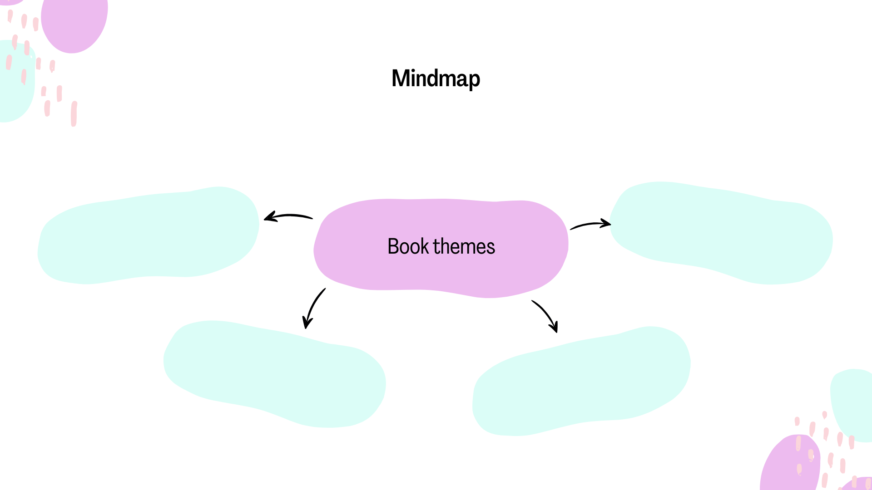A theme of a story is an important message in the story. What do you think the themes of this story might be? Fill in the mind map below with your ideas.

Click or tap here to enter text.

Click or tap here to enter text.

Click or tap here to enter text.

Click or tap here to enter text.

1. A large part of this story **is set** in Italy. This means that it happens in Italy. Have you ever visited Italy? If not, would you like to? Why/Why not?

Click or tap here to enter text.

# After You Read - Present Simple Tense



|  |  |
| --- | --- |
| **Subject** | **Conjugation** |
| I | am |
| You | are |
| He/She/It | is |
| We | are |
| You (plural) | are |
| They | are |

**Verb: To Be Verb: To Work**

|  |  |
| --- | --- |
| **Subject** | **Conjugation** |
| I | work |
| You | work |
| He/She/It | works |
| We | work |
| You (plural) | work |
| They | work |

**Note**

For **regular verbs** like "to work," we add **-s** or **-es** only for the **third person singular** (he/she/it).

We use the Present Simple for the following situations:

1. To talk about routines.

Example: I get up every day at 6am.

1. To talk about permanent situations.

Example: I live in Barcelona.

1. To talk about future scheduled events (according to a timetable).

Example: The bus leaves at 10.40am.

1. To talk about general truths and facts.

Example: Water boils at 100 degrees Celsius.

1. To talk about general abilities.

Example: I play the piano

1. To talk about feelings

Example: I feel happy today



Example Sentence Practice

Try to write your own example sentences for each of the rules above.

To talk about routines.

Click or tap here to enter text.

To talk about permanent situations.

Click or tap here to enter text.

To talk about future scheduled events (according to a timetable).

Click or tap here to enter text.

To talk about general truths and facts.

Click or tap here to enter text.

To talk about general abilities.

Click or tap here to enter text.

To talk about feelings.

Click or tap here to enter text.

# Reading practice



Read the following text and find an example of each rule in the text.

Italy offers a blend of rich history, vibrant cities, and incredible landscapes. Every day, Italians embrace routines that reflect their strong cultural identity, and this often involves family gatherings, coffee breaks, and evening strolls, or *passeggiata*. Italians generally begin their day with a quick espresso, which they drink standing at the bar before heading off to work or school.

As a country, Italy values family, food, and tradition, which has remained unchanged over centuries. Italians feel a deep connection to their heritage, and family is central to everyday life. Across the country, historic buildings, grand piazzas, and traditional markets remind visitors of Italy’s rich past. Cities like Rome, Florence, and Venice are famous worldwide, and these beautiful cities continue to attract millions of tourists each year.

Italy’s transport schedules make it easy to explore. High-speed trains depart regularly between major cities, such as Milan and Rome, allowing people to travel efficiently across the country. Whether it’s a train at 8:00 AM or 2:00 PM, Italian timetables follow a precise schedule that locals and tourists alike depend on.

In addition to its iconic sights, Italy boasts undeniable cultural facts. For example, it is widely known that Italy produces some of the world’s finest wine and olive oil. Italian cuisine also holds a special place globally, as people around the world enjoy pasta, pizza, and gelato, which are part of daily life in Italy.



Many Italians have a natural ability to communicate effectively and warmly with others, often using hand gestures as an expressive tool. This skill helps them connect with visitors and share their local insights. Italians also navigate narrow streets and bustling city centers effortlessly, showcasing their knowledge of urban life.

Overall, Italians feel pride and passion for their country. They often say that life in Italy isn’t just about work; it’s about enjoying moments with loved ones, savouring delicious meals, and appreciating the art, fashion, and culture that make Italy truly unique.



To talk about routines.

Click or tap here to enter text.

To talk about permanent situations.

Click or tap here to enter text.

To talk about future scheduled events (according to a timetable).

Click or tap here to enter text.

To talk about general truths and facts.

Click or tap here to enter text.

To talk about general abilities.

Click or tap here to enter text.

To talk about feelings.

Click or tap here to enter text.

# Writing practice



Marge spends most days at the beach writing her book.

Imagine you are Marge; write about a typical day in your life.

Click or tap here to enter text.

# Past Simple Tense



Verb: To be (irregular verb) Verb: To work (regular verb)

|  |  |  |  |  |  |  |  |  |  |  |  |  |  |  |  |
| --- | --- | --- | --- | --- | --- | --- | --- | --- | --- | --- | --- | --- | --- | --- | --- |
| |  |  | | --- | --- | | **Subject** | **Conjugation** | | I | was | | You | were | | He/She/It | was | | We | were | | You (plural) | were | | They | were | |  |

|  |  |
| --- | --- |
| **Subject** | **Conjugation** |
| I | worked |
| You | worked |
| He/She/It | worked |
| We | worked |
| You (plural) | worked |
| They | worked |

**Note**

**Regular** verbs like "**to work"** form the past simple by adding **-ed** to the base form. Several verbs form their past tense in an irregular way.

We use the past simple to:

1. Talk about single completed actions in the past.

Example: I washed the dishes after dinner.

1. Talk about repeated actions in the past that don’t happen now.

Example: My father walked to school every day when he young.

1. Past states.

Example: I knew her when we were in school.

Example Sentence Practice

Write your own example sentences for each of the rules above.

Talk about single completed actions in the past.

Click or tap here to enter text.

Talk about repeated actions in the past that don’t happen now.

Click or tap here to enter text.

Past states.

Click or tap here to enter text.

# 

# Reading practice



Read the following text and find an example of each rule in the text.

Two years ago, I spent a memorable summer in France. I stayed with a friend in a small village in Provence, surrounded by lavender fields and vineyards. Each day brought something new, but I still remember the peaceful rhythm of life there. Every morning, I walked to the village bakery, where I bought a fresh baguette. The baker knew me after a week and always greeted me with a warm smile, asking about my plans for the day. It became a comforting routine, one I sadly left behind when I returned home.

Throughout my stay, I visited nearby towns and explored their local markets. I tried traditional foods like *ratatouille* and *bouillabaisse*, which quickly became my favourites. My friend and I often went for evening strolls, passing by quaint cottages and sunflower fields. We also attended several *fêtes*, or village festivals, where locals celebrated with music, dancing, and endless laughter.

France felt timeless to me. The slow pace of life, the historic stone buildings, and the friendly people created an atmosphere that seemed unchanged for generations. Looking back, I see it as a place filled with a certain charm and grace that I haven’t found anywhere else.

Talk about single completed actions in the past.

Click or tap here to enter text.

Talk about repeated actions in the past that don’t happen now.

Click or tap here to enter text.

Past states.

Click or tap here to enter text.

# Writing practice



Imagine you are Tom. You arrived in Mongibello last night. Write a letter to Mr Greenleaf and tell him about your journey to Italy.

Click or tap here to enter text.

# Past Continuous Tense



We use the past continuous to talk about:

1. Actions in progress at a point in the past.

Example: I was walking my dog at 7am this morning.

2. Temporary situations in the past.

Example: I was staying in a friend’s house until my apartment was ready.

3. Annoying past habits (usually used with always).

Example: My sister was always borrowing my clothes without asking when we were teenagers.

1. Arrangements and plans for the future in the past.

Example: I was excited because I was meeting my sister for lunch later that day.

We also use the past continuous to talk about:

1. Actions in progress over a period of time

Example: I was walking my dog all morning.

1. Two actions in progress at the same time

Example: I was talking to my sister on the phone while I was walking my dog.

1. Background information in a story

Example: The sun was shining and birds were singing. Suddenly, I heard a big crash!

The past simple and the past continuous are often used together to show that one action happened (past simple) to interrupt another action (past continuous).

Example: I was washing the dishes when the phone rang.

# Reading practice



Read the following text and find an example of each rule in the text.

Last summer, Lucy was staying with her grandparents in the countryside. Every morning, she was waking up to the sound of birds singing outside her window. While she was helping her grandmother in the garden, her grandfather was always reminding her to wear a hat, which sometimes annoyed her.

One afternoon, while they were preparing a picnic for the next day, Lucy noticed that her grandparents were planning a surprise visit to the lake. She was looking forward to it, even though she knew it was just a short stay.

On the day of the picnic, Lucy was carrying the basket while her grandmother was setting up a blanket by the lake. They spent hours there, just chatting and enjoying the breeze. As the sun was setting, Lucy and her grandmother were watching the sky turn pink and orange, creating a perfect end to the day.



Actions in progress at a point in the past.

Click or tap here to enter text.

Temporary situations in the past.

Click or tap here to enter text.

Annoying past habits (usually used with always).

Click or tap here to enter text.

Arrangements and plans for the future in the past.

Click or tap here to enter text.

Actions in progress over a period of time.

Click or tap here to enter text.

Two actions in progress at the same time.

Click or tap here to enter text.

Background information in a story.

Click or tap here to enter text.

# Writing practice



You are Dickie. Write a journal entry describing the day that Tom arrived in Mongibello. Include the following: what you did that day; what you were doing when Tom arrived; how you felt about his arrival and your first impression of him.

Use at least 3 examples of the past continuous and past simple.

Click or tap here to enter text.

2nd Conditional Tense



We use the 2nd Conditional to talk about imaginary or hypothetical situations.

To form this tense, we use:

**If + past simple, would + infinitive**

Example: If I won the lottery, I would travel the world

If I saw a ghost, I would scream.

We can also use other modal verbs such as could or might, instead of would.

Example: If I won the lottery, I could leave my job.

I might run away if I saw a ghost.

Gap fill exercise



Complete the exercise below with the correct form of the verb in brackets.

1. If I _______ (have) more free time, I would _______ (travel) around the world.
2. If she _______ (know) how to cook, she would _______ (invite) us for dinner.
3. If they _______ (live) closer, we would _______ (see) each other more often.
4. If it _______ (not rain) so much, we would _______ (go) to the beach.
5. If I _______ (be) you, I would _______ (talk) to the teacher about it.
6. If he _______ (study) harder, he would _______ (pass) the exam.
7. If we _______ (win) the lottery, we would _______ (buy) a new house.
8. If she _______ (speak) Spanish fluently, she would _______ (move) to Spain.
9. If I _______ (find) a good book, I would _______ (read) it all night.
10. If they _______ (have) a car, they would _______ (drive) to work every day.

# Reading practice



Read the following text and find 6 examples of the 2nd conditional tense.

Alex had always dreamed of being a musician, but he spent most of his days working in an office. He often imagined what his life would be like if he could perform on stage every night. If he didn’t have so many responsibilities, he would pack his bags, move to a big city, and start a new life. He knew that if he took the risk, he might have a real chance to succeed, but he felt trapped by his steady, predictable job.

One evening, his friend Ella asked him, “If you had the opportunity to play with a famous band, would you take it?” Alex smiled and replied, “Of course! If that happened, I would feel like my dreams were finally coming true.”

Ella nodded and said, “Well, if you don’t try, you’ll never know what could happen. You should start small—if you joined a local band, you’d still get a taste of the life you want.”

Alex laughed, imagining the possibilities. If he played just one live show, he knew it would change everything for him. His heart ached with excitement at the thought, but he told himself it was just a fantasy.



1. Click or tap here to enter text.
2. Click or tap here to enter text.
3. Click or tap here to enter text.
4. Click or tap here to enter text.
5. Click or tap here to enter text.
6. Click or tap here to enter text.

# Writing practice



If you could start a new life tomorrow, where would you go and what would you do?

Click or tap here to enter text.

# Vocabulary



The characters

1. Who is your favourite character in the story? Why?

Click or tap here to enter text.

1. An adjective is a describing word. It gives more information about a noun.

Example: There is a **big** car outside.

Big is the adjective. It describes the car.

Some examples of adjectives of personality are: friendly, happy, brave and kind.

Use 3 adjectives of personality to describe each of the characters below:

Tom Click or tap here to enter text.

Dickie Click or tap here to enter text.

Marge Click or tap here to enter text.

Freddie Click or tap here to enter text.

Mr Greenleaf Click or tap here to enter text.

Mrs Greenleaf Click or tap here to enter text.

Alvin McCarron Click or tap here to enter text.



1. Imagine you are the writer, Patricia Highsmith. You are going to add a new character to the story. Who are they connected to? What 3 adjectives of personality would you use to describe them? How would the story be different if they were in it?

Click or tap here to enter text.

1. How did you feel about Fiona at the beginning of the story?

How did you feel about her at the end?

Click or tap here to enter text.

# Crossword



Print this page and complete the crossword below using the clues given.

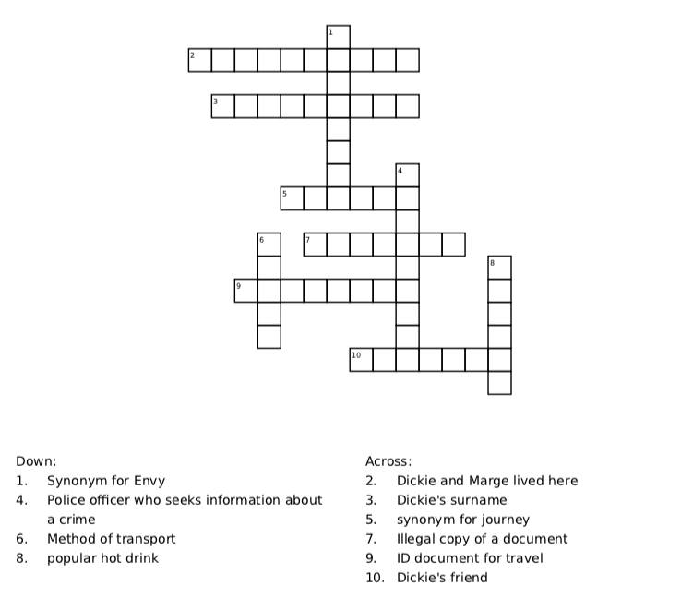Or you can complete this [crossword online](https://worksheets.theteacherscorner.net/make-your-own/crossword/play-crossword.php?data=eNpVkkFvnDAQhf-Kb71YEQZjwL7mkkOkqs0ZyQGzOAs2MrAVEj--b9iqVS_z4TfzxjMWQnGhzo_RsQ87ubC5nr0n9sMvkzvOjItCP4wgRJMTDlNwpRdEIfRGyHUiFNoSpPaEUgcjudQDokJG8kbPiCi7mRKJhKj0iljrDrHBBSUXGRwltb6Qa0coAAUPRfIoVAdT8Ry9Kug9Is1UQb-ZmtNE9aXX0CNig6kaTu0aLq9vhZoG-qcR2BKlAOWBAnsB8nkqMR6gnmIFM1DTq2Swo0TAFwiNnozIcbpwnYpnzwKGgUBbAlgzXRSYVxTPRcX1iE9d4p2F5Jn-IgjKSrSyhIIa09tGQql3Aj0LUJGvROVgTtsW7bvbxtizOLAt2bAuMW3Gtqr9Hpd9somNcWN98uH-ArmGPPnOoXwAEvs1RrY6d1-ZD0NMs918DMx-xn1jlnXJz458Tfs2Te5mJ9bF5aDLLOtjt8_4nSgvsvbnEWI4ZoYuzIXH8WL6VvynfsU9BXcl8vbt9W-DK4nhH26inGxffXf37tvKhuRd6Eks_4jMBvy9Nt0cm_wDf_LokqOC6p9rxTWW5j5xtzt_Awr03Nk%3D).

# Wordsearch



Find all the hidden words associated with the story in the wordsearch below.

Words are hidden in all directions. Or you can complete this [wordsearch online](https://thewordsearch.com/puzzle/8132282/the-talented-mr-ripley/).

Greenleaf mystery Marge jealousy theft

Dickie love identity Cannes

boat passport Greece Tom forgery

|  |  |  |  |  |  |  |  |  |  |  |  |  |  |  |  |  |  |
| --- | --- | --- | --- | --- | --- | --- | --- | --- | --- | --- | --- | --- | --- | --- | --- | --- | --- |
| f | m | d | c | p | f | g | m | a | r | g | e | c | o | i | g | d | k |
| o | y | a | s | q | g | v | m | v | e | j | o | a | o | d | r | a | h |
| r | s | d | c | a | b | b | j | o | k | o | x | n | c | e | e | d | p |
| g | t | n | a | b | o | o | n | e | g | i | i | n | m | n | e | q | a |
| e | e | w | g | w | g | f | a | w | a | q | l | e | c | t | c | q | s |
| r | r | i | i | i | q | c | w | t | z | l | x | s | t | i | e | t | s |
| y | y | i | e | r | z | n | f | a | k | c | o | d | z | t | t | h | p |
| w | h | u | g | r | e | e | n | l | e | a | f | u | u | y | o | e | o |
| c | r | l | p | v | y | l | e | p | k | w | e | c | s | f | m | f | r |
| l | o | v | e | n | m | z | z | k | o | u | s | n | v | y | x | t | t |
| x | z | m | f | f | s | v | e | w | c | e | a | m | f | s | b | r | t |
| a | k | d | c | e | y | d | i | c | k | i | e | s | o | b | l | e | i |

Money - Test yourself



Write 8 currencies from around the world in the spaces below:

Click or tap here to enter text. Click or tap here to enter text.

Click or tap here to enter text. Click or tap here to enter text.

Click or tap here to enter text. Click or tap here to enter text.

Click or tap here to enter text. Click or tap here to enter text.



Think about it.

1. We see in the story that Tom does terrible things for money.

Why do you think money is so important to him?

1. There is a saying “Money can’t buy happiness”.   
   Do you agree or disagree with this statement?

Travel



Travel is one of the many themes in this book.

Complete the mind-map below with words you associate with travel.

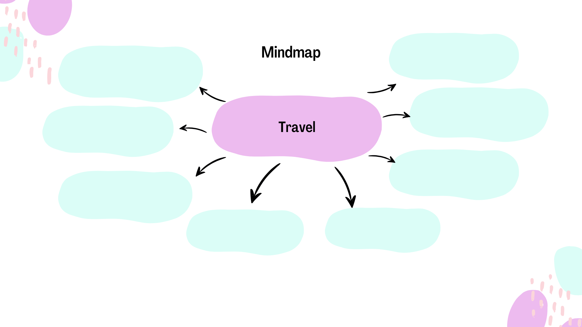

Click or tap here to enter text.

Click or tap here to enter text.

Click or tap here to enter text.

Click or tap here to enter text.

Click or tap here to enter text.

Click or tap here to enter text.

Click or tap here to enter text.

Click or tap here to enter text.

# Writing Practice



Imagine you are on the famous Orient Express. A mysterious train with many stories. Look around. Who is travelling with you on the train? Do you know them? What do they look like? Are you feeling suspicious of your fellow passengers?

Think about the beautiful landscapes and the smells and sounds along the way.

Write about how you are feeling on this journey.

Click or tap here to enter text.

# Exploratory Questions



1. Imagine you are a detective sent to interview after Dickie’s disappearance. What questions would you ask him?
2. What do you think will happen to Tom in the future? Do you think he will get caught? Why/ Why not?
3. Tom and Dickie travel to Cannes together. Research the area and plan an itinerary for a 5-day trip. What would you take with you? What form of transport would you take there?
4. The Greenleafs have a difficult relationship with their son. There are many famous family feuds in history. Research a famous family feud and write about it.
5. Imagine Dickie had survived. What do you think would have happened?
6. Tom is guilty of identity theft in this story. Can you think of any other famous books or movies based on a story about someone who steals other people identities?
7. If you were to change a part of this story, what would it be?

# Answer Key

Grammar - Present Simple Text

Hidden examples of present simple in the text:

1. To talk about routines: "Italians generally begin their day with a quick espresso, which they drink standing at the bar..."
2. To talk about permanent situations: "Italy values family, food, and tradition, which has remained unchanged over centuries."
3. To talk about future scheduled events: "High-speed trains depart regularly between major cities, such as Milan and Rome..."
4. To talk about general truths and facts: "Italy produces some of the world’s finest wine and olive oil."
5. To talk about general abilities: "Italians have a natural ability to communicate effectively and warmly with others..."
6. To talk about feelings: "Italians feel pride and passion for their country."

Past Simple Text

Hidden examples of past simple in the text:

1. Single completed action in the past: "One summer, when he was twelve, Liam saw a dolphin swimming near their boat."
2. Repeated actions in the past that don’t happen now: "Every weekend they went fishing together."
3. Past states: "Liam grew up in a coastal town, where he spent most of his childhood."

Past Continuous Text

Hidden examples of past continuous in the text:

1. Actions in progress at a point in the past: "Lucy was carrying the basket while her grandmother was setting up a blanket."
2. Temporary situations in the past: "Lucy was staying with her grandparents in the countryside."
3. Annoying past habits (with 'always'): "Her grandfather was always reminding her to wear a hat."
4. Arrangements and plans for the future in the past: "Her grandparents were planning a surprise visit to the lake."
5. Actions in progress over a period of time: "They spent hours there, just chatting and enjoying the breeze."
6. Two actions in progress at the same time: "While she was helping her grandmother in the garden, her grandfather was always reminding her to wear a hat."
7. Background information in a story: "Lucy was staying with her grandparents in the countryside."

2nd Conditional Gap Fill

1. Had / would travel
2. Knew / would invite
3. Lived / would see
4. Didn't rain / would go
5. Were / would talk
6. Studied / would pass
7. Won / would buy
8. Spoke / would move
9. Found / would read
10. Had / would drive

2nd Conditional Text

Hidden examples of 2nd Conditional in the text:

1. "If he didn’t have so many responsibilities, he would pack his bags and start a new life."
2. "If he took the risk, he might have a real chance to succeed."
3. "If you had the opportunity to play with a famous band, would you take it?"
4. "If that happened, I would feel like my dreams were finally coming true."
5. "If you joined a local band, you’d still get a taste of the life you want."
6. "If he played just one live show, he knew it would change everything for him."

Crossword

Wordsearch

|  |  |  |  |  |  |  |  |  |  |  |  |  |  |  |  |  |  |
| --- | --- | --- | --- | --- | --- | --- | --- | --- | --- | --- | --- | --- | --- | --- | --- | --- | --- |
| f | m | d | c | p | f | g | m | a | r | g | e | c | o | i | g | d | k |
| o | y | a | s | q | g | v | m | v | e | j | o | a | o | d | r | a | h |
| r | s | d | c | a | b | b | j | o | k | o | x | n | c | e | e | d | p |
| g | t | n | a | b | o | o | n | e | g | i | i | n | m | n | e | q | a |
| e | e | w | g | w | g | f | a | w | a | q | l | e | c | t | c | q | s |
| r | r | i | i | i | q | c | w | t | z | l | x | s | t | i | e | t | s |
| y | y | i | e | r | z | n | f | a | k | c | o | d | z | t | t | h | p |
| w | h | u | g | r | e | e | n | l | e | a | f | u | u | y | o | e | o |
| c | r | l | p | v | y | l | e | p | k | w | e | c | s | f | m | f | r |
| l | o | v | e | n | m | z | z | k | o | u | s | n | v | y | x | t | t |
| x | z | m | f | f | s | v | e | w | c | e | a | m | f | s | b | r | t |
| a | k | d | c | e | y | d | i | c | k | i | e | s | o | b | l | e | i |