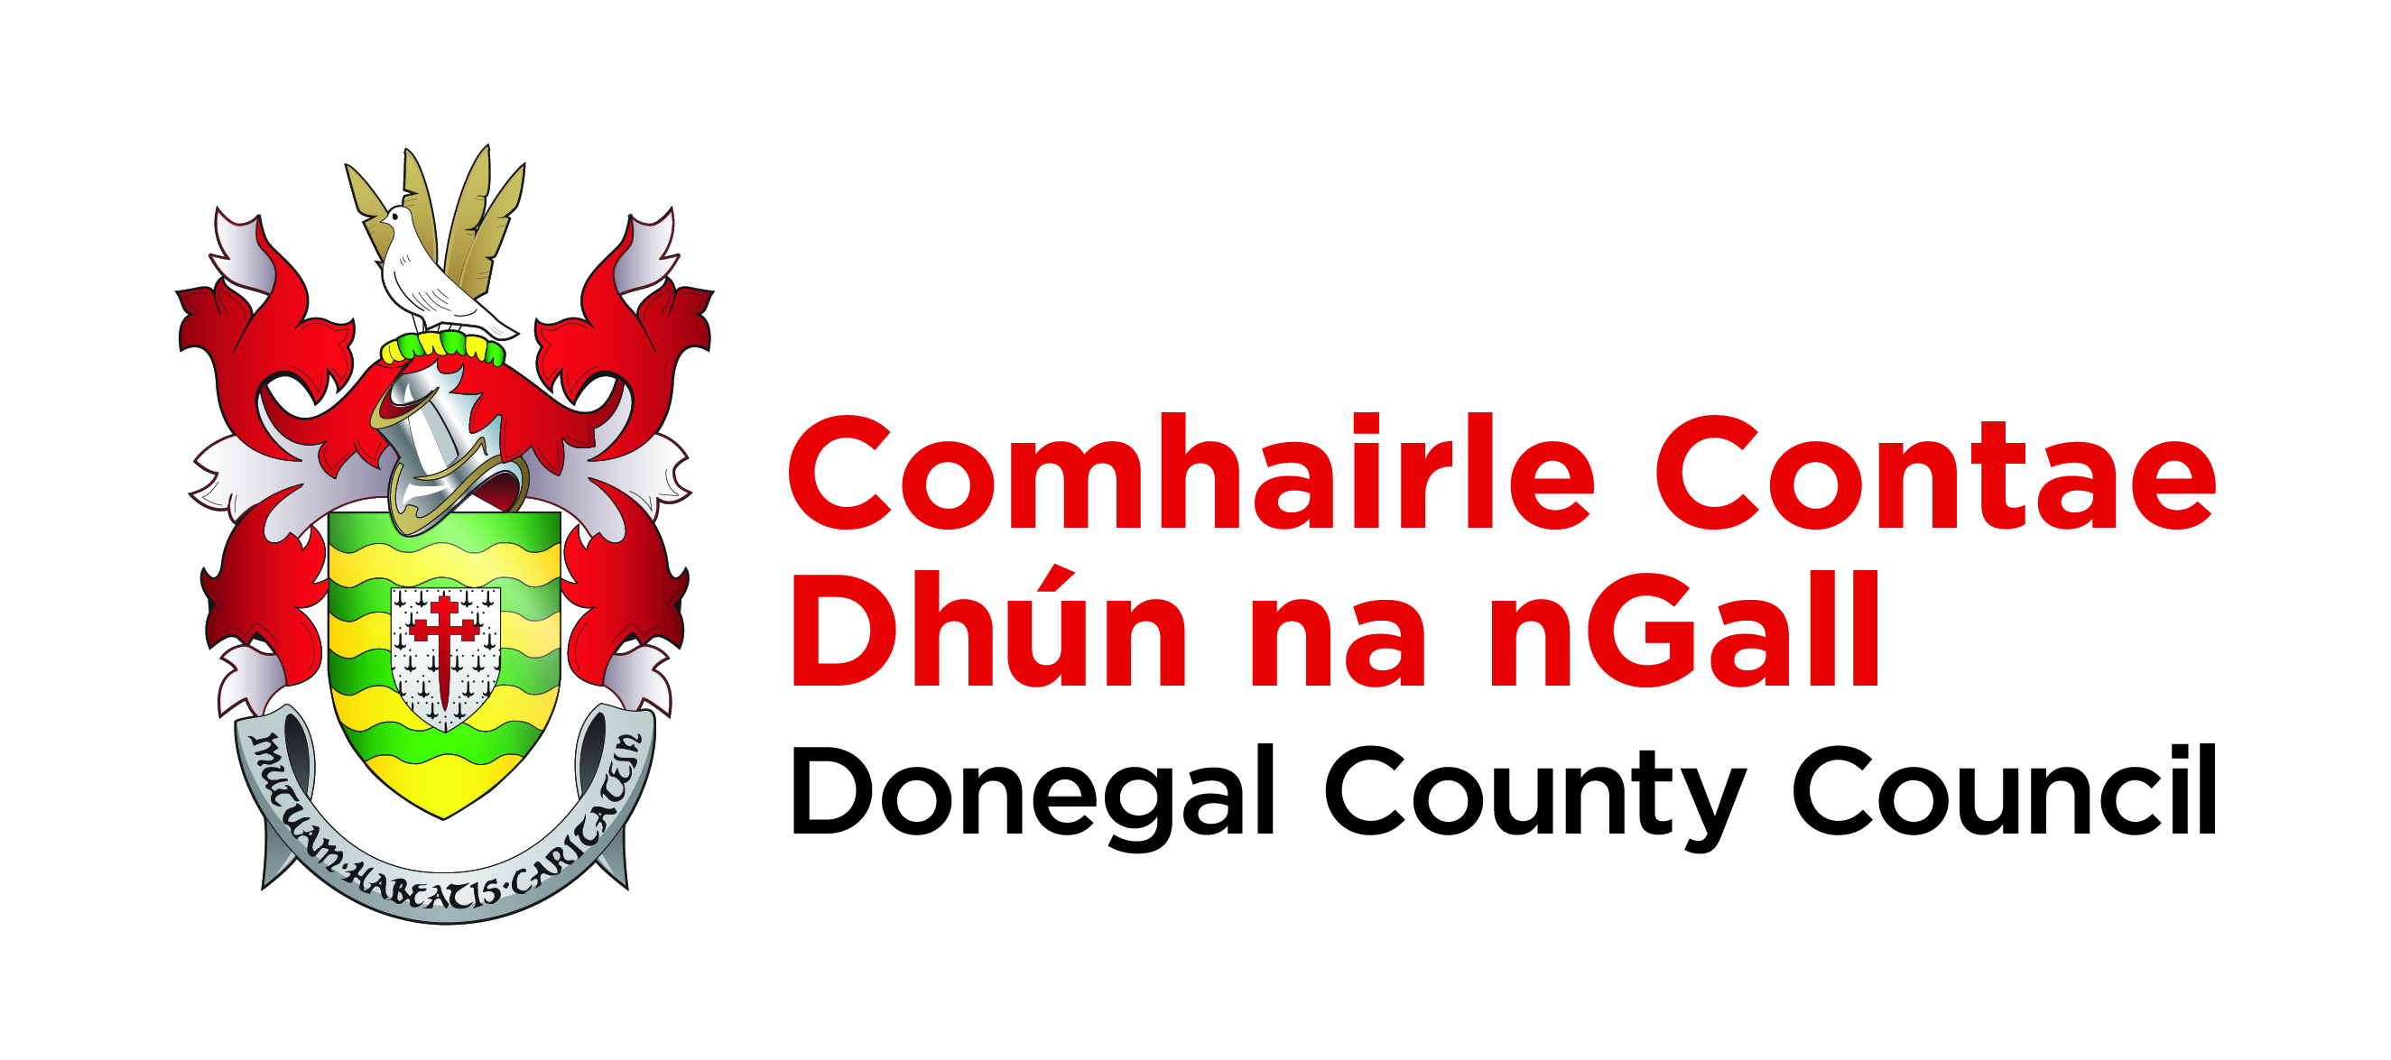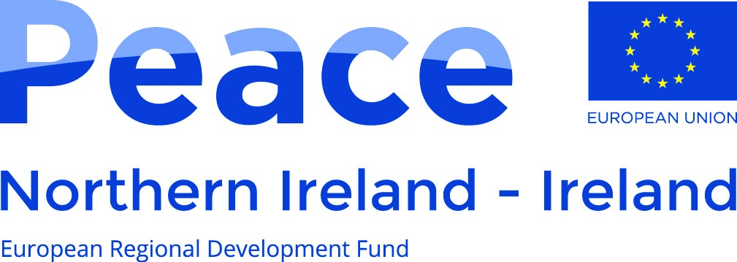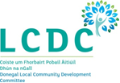

Echoes of the Decade – Oral History Strand
Interview Report Form
Name of Interviewer | Regina Fitzpatrick
Date(s) of Interview(s) | 7 October 2020; 9 October 2020; 14 October 2020.
Location | Phone interview –Paddy and Teish in Co. Donegal, Regina in Co. Kilkenny.
Name of Interviewee | Paddy and Teish Doherty
Gender | Paddy (male); Teish (female)
Year of Birth | Paddy (1940); Teish (1940)
Interview Synopsis
Paddy Doherty is from Carndonagh, Co. Donegal and is the son of PH Doherty, Company OC Carndonagh, OC 2nd Battalion, 2nd Donegal Brigade during the War of Independence. In this series of three joint interviews with Paddy and Teish, Paddy talks about life growing up in Carndonagh, his father’s involvement in the War of Independence and Civil War and themes such as politics, community life, the GAA, the economy, the border, the Northern Ireland Troubles and running his newsagents. Paddy’s wife Teish is from Glentogher, Co. Donegal and had a long career as a national school teacher and principal. Teish talks with great richness about the experience of rural life in Donegal in the twentieth century focussing on themes such as emigration, education, the Catholic Church, poverty, smuggling and the lives of women.
Time-Coded Interview Summary
Interview 1: 7 October 2020
00:00 Interview Introduction.
00:35 Paddy talks about being born and raised in Carndonagh. Describes the Carndonagh of his childhood, mentions playing Gaelic football and hurling with his twin brother and the other children on the road.
01:52 Talks about learning to dance at the dances in the Colgan Hall and moving on to the Borderland Dancehall in Muff in later years. A well-known dancehall that attracted bands such as Mick Delahunty and Clipper Carlton.
02:42 Meeting his wife Teish McLaughlin from Glentogher and getting married in 1965. Had six children together. Playing golf in their retirement.
03:48 Economic life in Carndonagh in the 1940s. Talks about starting to work in the family shop when he was around 16. Mentions ration books during World War II.
05:32 Teish talks about her father, Jock, smuggling during the time he was working with the Americans in Lisahally in Derry in the 1940s. His father’s biked ‘geared up’ for smuggling. Smuggling whiskey into Derry, butter and flour smuggled out, razors and stockings also smuggled. Story about her father’s coat sewn to hold lots of whiskey bottles.
07:43 ‘Butter buses’ coming out of Derry through Customs and Excise. How butter was smuggled on these buses.
08:40 How women smuggled butter in their clothing. Smuggling a big industry. Various stories about her father smuggling flour and other supplies on his bike.
10:09 Flour and butter smuggled out of the North. Whiskey and other spirits, nylon stockings and razor blades smuggled in. Poitín making in the area. Teish’s father smuggling timber down the Foyle to Quigley’s Point. People made a good living out of smuggling.
13:43 Teish is from Glentogher. She was taught by the Mercy nuns in Glentogher and before attending the Loreto Preparatory College in Falcarragh after winning a scholarship.
15:27 Attending Carysfort Teacher Training College in Dublin, 1958-1960. References the Marriage Ban for teachers. Mentions deductions in their teaching salary to cover the cost of their training.
17:04 Scarcity of work after she came out of college. Also mentions St Patrick’s College, Drumcondra.
18:05 Starting her teaching career in a small school in Glencolmcille. Talks about Fr James McDyer as her manager there. Life working in a one teacher Gaeltacht school as a new teacher.
20:30 Became Principal of the All-Boys school in Carndonagh where she worked until 1998. Reference to the marriage ban.
23:05 Teaching of history in schools in Teish’s school days and in her time as a teacher.
24:47 Story about the Black and Tans going into her mother’s house, her mother was Agnes Kelly from Magheramore and Agnes’s mother was Bridget Kelly.
26:28 Her mother’s emigration to Scotland and her parent’s marriage there. Father’s life working in England, dependence of the family on his income being sent home.
27:05 Her mother worked for the Tilly and Henderson Shirt Factory before she married. Burning down of the factory. Mother emigrated to Scotland after this and worked at Dykebar Hospital. Worked subsequently for a thread mill in Paisley and married Teish’s father in 1938. Left when World War II broke out. Story about their journey back to Ireland.
29:13 Teish’s father travelling over and back to England to work for most of his life as many men did. Men travelled to Scotland ‘tatti hoking’, pulled sugar beet in England and went to work for big farmers in England. Women at home running small holdings. Her father also worked on dairy farms there and on building sites. Irish men and the building of Britain, what the lives of Irish men were like in England in the 1940s to the 1960s. Mention of contractors and Tilbury Docks.
33:30 How Teish’s mother coped with home taking care of eleven children, older relatives and a farm. Death of Teish’s brother as an infant. Working at turf, hay or potatoes, doing schoolwork as a child. The difficult life of country people in Ireland in the mid-twentieth century. Receiving additional tuition from the nuns. Basic diet people had in her childhood.
37:34 Size of families in the area. Lives of rural women in those times. Childbirth and miscarriages. Basic facilities for washing, open fire, churning, gathering blackberries to sell. Her mothing sewing to make extra money.
39:30 Influence of the church in how people lived their lives. Description of the practice of ‘Churching’. The church’s treatment of women.
41:45 Teish’s father lived until he was 98 and always worked. After his retirement set up a bicycle shop. Her mother lived until she was 95.
43:23 Talks about her parents having lived through two World Wars then living to see the Northern Ireland Troubles.
44:35 Teaching in Carndonagh during the Troubles in Northern Ireland. Paddy attending marches in the North at the beginning of that period and the subsequent escalation of the Troubles. Going through check points at Muff and Aughnacloy. Detours through back roads. Mentions the UDR. Avoiding Derry at that time.
47:50 Role of schools in the care of children during The Troubles. Atrocities that happened in Inishowen during the Troubles.
49:15 Paddy continues the interview. Talks about his family owning the newsagents in Carndonagh. Mentions the National Federation of Newsagents. Mentions Dessie O’Malley’s change of legislation concerning newsagents.
50:10 Talks about the delay in newspapers coming in the day after Bloody Sunday, mentions the Irish Press and Irish Independent. Town closed down for three days after Bloody Sunday, Paddy selling papers from his car during these days. Killing of Oliver Boyce and Bríd Porter from Buncrana in 1973. Tension after this incident.
52:30 IRA men operating around Inishowen at the time. Arms find at the Five Fingers strand. Mentions his brother in law Des Matthews, the secretary for the Department of Justice at the time. Mentions Eamonn Doherty, former Commissioner of An Garda Síochána.
54:53 Not knowing who was involved in the IRA in the area. People being cautious. Lack of understanding of what people from border counties went through during the Troubles.
56:36 Talks about Bishop Farren starting a secondary school in Carndonagh in the Colgan Hall in 1960, no secondary school in the area before that. People could not afford to send their children to St Eunan’s in Letterkenny or to St Columb’s in Derry.
57:44 Sr Eugenius establishing a junior comprehensive school for girls against the wishes of the Bishop.
58:09 Teish continues the interview to talk about Sr Eugenius and her establishment of the school in Carndonagh and the subsequent development of the Community School.
1:00:25 Paddy talks about cost of sending a child from Donegal to a university. Lack of public transport in Donegal. Closure of the railway in 1932. Resilience of Donegal people to do things for themselves.
1:03:23 Story about his father PH Doherty and his work forming a committee to employ a district nurse in Carndonagh in the 1950s. System of money collection by local people to pay the nurse set up my PH and Maggie Doherty. Fundraisers such as dances to support local services. Nurse travelling around the district on her bicycle.
1:05:50 Mentions Connor’s forge and talks about the local dispensary and Dr Friel. Talks about the old workhouse which became a diphtheria hospital. Building of new hospital.
1:07:05 Strength of local community. The building of the Colgan Hall, built in 1914. Mentions Fr Philip O’Doherty who was parish priest at the time. Starting of the vocational school in the Colgan Hall in the 1930s. More recent renovations of the hall and activities that happen there now. Hall named after a Franciscan monk from the area called John Colgan who was involved in the Four Masters and travelled to Louvain.
1:09:20 Talks about his father and John Kelly and James Bogs setting up a Development Committee in Glengad to try to house people and teach people the trades needed to build a house in 1955. Assisted by Pat Collins from Glengad who provided sheds where Philip and Seamus McLoughlin held night classes to teach the skills to people. Mentions the Utilities Society. Fifty-five new houses built in five years.
1:12:20 His father knew people from Glengad having trained a platoon of the LDF in the Black Mountain.
1:13:55 Interview 1 ends.
Interview 2: 9 October 2020
00:00 Interview Introduction.
00:30 Teish talks about the Sisters of Mercy and their contribution to society in Carndonagh, include Sr Eugenius. Discusses poverty, housing, unemployment and education. Nuns going out to Glentogher to teach in the school there, driven by Jim Butler. The nuns’ contribution to the welfare of children.
03:45 Clothing of children in Teish’s childhood, sharing of clothes, handing down of clothes, school clothes, work clothes. Nun’s in the role of social workers in those days.
04:55 First communion class being taken into the convent and served tea, toast and treats and nun’s providing a gift to each child. Provision of tuition for young girls going to take their exams to train to be nurses and help in arranging accommodation in England. Tutoring of students in Irish to prepare them for their examinations to enter An Garda Síochána. Community support of the convent and the nuns.
08:08 Teish’s experience of the Sisters of Mercy and Loreto nuns in Falcarragh and Carysfort College Dublin. Talks in particular about her teacher Sr Teresa, from Glenties in Co. Donegal.
09:43 Corporal punishment.
10:45 Convent closed in the mid-1980s without the recognition they deserved in Teish’s view. References church scandals that were emerging at the time.
12:00 Community self-reliance and spirit in Carndonagh. Covid-19 rates in Carndonagh at the time of the interview.
13:00 People gathering for the threshing of corn in bygone days. Gathering of people for wakes and funerals. Neighbours helping each other out on farms.
13:55 Story about her father borrowing money for his sister from a Protestant neighbour, James McMonagle. Relationships between Catholics and Protestants in Teish’s community when she was growing up.
15:44 Contrasts panic buying during Covid 19 pandemic with the scarcity of food during World War II. Talks about rationing during the war.
16:43 Protestant children attending the convent school when she was a child.
17:11 Describes in detail the emphasis on the teaching of religion and the examination of children in Religious Studies in schools in the diocese of Derry in her childhood. Gives example of questions from the catechism taught. Describes the pressure on teachers and the difference of the approach in Glencolmcille as she experienced it as a teacher there when the Ecclesiastical Inspector came.
23:09 Teish describes the government Free Shoes Scheme.
25:18 Fragmented political scene in Ireland in her childhood, the country was just recovering from the turmoil of the War of Independence and Civil War and also from the affects of World War II.
26:15 Elections and canvassing. Talks about de Valera canvassing in Carndonagh and further back in history Daniel O’Connell had a rally on the Green Hill outside Carndonagh. Talks about crowds of people gathering in the Diamond for rallies.
27:28 The prominence of politics in her childhood. Mentions Clann na Poblachta. Use of the school as a polling station.
29:30 The life of women in mid-twentieth century Ireland. Music in the house as a social occasion for women. Women in the home. Selling of eggs and ‘country butter’ in lieu of the week’s messages, described by Teish. Going to mass. Travelling by pony and trap, horse and cart and by bicycle. Sewing, knitting, crocheting and spinning wool, weaving. Coopering industry making spinning wheels. Status of women.
34:15 First major improvement to women’s lives came in the 1960s when women were allowed to collect their own old age pension for the first time. The first-time women had their own money.
38:15 Her mother’s enjoyment of having her own money in her old age. Having a hot whiskey with her friend on pension day, going to the amusements and doing her shopping.
39:00 Teish was in Carysfort Teacher Training College from 1958-60 between the age of 18-20 yrs. Rules of the college. Newspapers were not allowed in the college. 1964 strike in Caryfort protesting the rigidity of the regime and the impact of this on how the college was run subsequently.
42:25 The church and state keeping women ‘in their place’. Women not allowed to participate in public life or offer opinions. Changes of the 1960s.
44:08 Changes that have taken place in one generation, comparison of her youth to the freedom women enjoy now. References the local golf club as an example.
45:50 Paddy resumes the interview. Life working in the shop. Paddy’s four sisters went to school in the Mercy Convent in Carrickmacross. How they travelled there.
47:14 Paddy talks about the work involved in running the shop. Talks about various food stuffs, how they were measured out. Mentions egg merchants. People gathering in the shop to talk. His father talking politics in the shop.
49:20 Talks about the by-election in 1948. Paddy remembers De Valera coming into Carndonagh, led into the town by a torch light procession to a large crowd in the Diamond. Dr McGinley up against Neil Blaney, Blaney went on to win election. Paddy talks about canvassing for Fianna Fáil with Kathleen Byrne around the area.
51:43 Mentions his friend Seán Kelly, travelling around to dances together. Worked very hard in the shop and farm but also had a good time. His father expected him and his twin brother to work hard.
53:00 His father’s father had emigrated to America and returned home around 1880. Talks about emigration in his father’s family. His grandfather bought a farm in Glasha and married Mary Glackin from Mallin Head. He died when he was 60.
54:10 His father’s employment with the Department of Agriculture in 1917 and working around the Letterkenny area, used to travel around by bicycle. His father losing his post after he became involved in the Irish Volunteers. His father never talked much about his involvement in the Revolutionary period but he had full military honours in his funeral.
55:29 PH Doherty was District staff leader of the LDF in Inishowen in Paddy’s childhood. Paddy reads out some names of those involved in the LDF from a photograph. LDF formed as a reserve army during the Emergency.
57:52 Description of Carndonagh in the 1940s. The people in town who had cars. Tells a story about his own first car. Field days in the town at the time. The Red Cross in the area. The building of the council offices in Carndonagh.
1:00:57 The generation of people who were involved in the War of Independence and Civil Was did not tend to talk about it. PH Doherty was also a Peace Commissioner. How busy the shop was at the time.
1:02:48 Memory of the Bureau of Military History coming to interview his father to take his Witness Statement in 1956. Mentions Garda Meehan from Bruff, Co. Limerick who set up the first Garda Barracks in Carndonagh.
1:03:45 His father as a prominent person in the town and good work he did. He came from a humble background. House was run ‘like a military barracks’, hard work was expected, he was a strict man. Had a strong sense of community. He never left Ireland which he regretted. Talks about his trips to Dublin to Easons to do business. Had a lot of good friends. Very involved in the St Vincent de Paul Society.
1:07:05 Salmon fishermen coming from Glengad to had forms signed and to have him take care of things for them. His father as a well-known figure in Inishowen. He was a Fianna Fáil supporter. Re-iterates that his father did not talk about the Civil War.
1:08:36 Describes the 50th Commemorations of the 1916 Rising in 1966 in Carndonagh.
1:09:27 Talks about his sense that the strength of the flying column his father led was so strong that it saved Inishowen from being taken in to the six counties. All of his involvement in that period faded into the background. His father died in 1978 during the Northern Ireland Troubles. A lot of people in Inishowen were sympathetic to the Republican cause during the Troubles. A lot of IRA activity in Inishowen at that time.
1:12:02 Comparison between the Old IRA and the Provisional IRA. Atrocities that happened in the area during the Troubles. Tension and eeriness in Carndonagh during the Troubles, particularly after of Bloody Sunday.
1:15:47 Paddy’s mothers brother Niall Conway fought and was killed in World War I.
1:16:10 Story the locating of the County Council offices in Carndonagh. Mentions Barney McGlinchey (who as a Senator), Paddy Harte, Fine Gael TD and Philip McLoughlin.
1:18:11 Interview 2 ends.
Interview 3: 14 October 2020
00:00 Interview Introduction
00:35 Paddy tells the story of the building of the Church of the Sacred Heart in Carndonagh during World War II. Talks about the fundraising campaign.
03:02 Mentions History of Carndonagh by Maura Harkin and Sheelagh McCarroll and the Carndonagh Heritage website.
03:37 Teish talks about setting up Colgan Heritage in Carndonagh with Seán Beattie. Talks about the life of John Colgan, a Franciscan monk from the sixteenth century after whom the Colgan Hall and Colgan Heritage is named. Mentions the Four Masters and the Trias Thaumaturga which he wrote. Mentions St Isador’s Library in Rome where his writings can be found. Talks about the work of Colgan Heritage and the work of Maura Harkin.
08:42 Commemoration of the Decade of Centenaries with the heritage group. Mentions cross border projects, one with a group from the Waterside in Derry called History Links funded by Peace III. Publication of book from project and a later schools project. Also mentions an art-based project with John O’Connor. Mentions work researching the workhouse graveyard where babies who died before baptism would have been buried.
13:00 Mentions heritage trail that they set up around Carndonagh and a cemetery digitisation project. Talks about the experience of working on cross-border projects. Mentions Heather McLoughlin who is involved in these projects.
14:45 No monuments commemorating the Revolutionary period in Carndonagh. Mentions Seán Beattie and Paddy Harte. Mentions the Donegal Book of Honour.
16:54 Heritage of people who fought in World War I in the area. Mentions the plane that crashed at Glengad during World War II. The funerals of those soldiers.
18:05 Paddy tells the story of the plane crashes at Glengad and Gleneely during World War II.
19:55 Emigration from Carndonagh in the 1950s to England and also to Scotland to work on the hydro-electric schemes. Paddy talks about the lack of government investment in Donegal and the loss of garment businesses such as Fruit of the Loom, Tilly and Henderson and JBs factory in the area.
21:44 The expense of sending their children to university in Dublin.
22:58 The GAA in Carndonagh of which Paddy is an honorary member. Growing up playing hurling and football in the park in the town. Mentions the parish leagues. Mentions Neddie Kelly who sold the grounds to the GAA. Paddy’s father went guarantor for the field at the time. Park named after a teacher called Mick Doherty, a prominent man in the GAA and in Fianna Fáil. He died around 1950.
27:22 A lot of young men around the time at the time. Rivalry between Carndonagh and Burt. Paddy played for Donegal against Antrim in the year of An Tóstal in Carndonagh.
28:28 Describes An Tóstal initiative in the 1950s.
29:30 Emigration from the area. Ten young men emigrated in one day from Cardonagh in the 1960s.
30:48 Protestants not involved in the GAA club, they could not play sport on a Sunday. Some played during the week but not in the games on Sunday.
31:41 Mentions Fr Chapman who ran the School Sports on the 29 June each year and protestants could participate in that as it often didn’t take place on a Sunday. Mentions the badminton club in the town.
32:35 Travelling to matches over the years. Travelling over the border to leagues in Derry. Won the U16 county championship in 1956, Paddy and his brother Liam played in that. The match was played in Glenties against Gweedore. Tom Farren was in charge. Very few people travelled to the match. Some of the players were attending St Eunan’s or St Columbs where football was strong. More recent Carndonagh victories.
34:40 GAA as a focal point for the community. Description of the amenities and facilities. Mentions Jimmy McDaid who was Minister for Sport for a time and he assisted all of the sports organisations in Donegal.
35:45 Story about going to Dublin for the first time and staying with his sister in her house on Griffith Avenue. Travelling to the match in a van and stopping off to see Oliver Plunkett’s head in Drogheda. Derry was playing that time.
37:12 Ulster Final days in Clones, being delayed going through check points at Aughnacloy on the way to matches. Being stopped on the way to matches in the North. That ended with the peace process.
40:14 What the GAA means to Paddy. All of his family played, his son Darragh played U21 with Donegal. His daughter has All-Ireland medals for camogie with NUI Maynooth. GAA part of his identity.
41:55 Listening to matches on the radio. Story about meeting Micheál Ó hÉithir.
43:24 GAA during the Troubles. Proximity to the border. Number of people who travel from Carndonagh into the North to work.
44:30 Legacy of the Revolutionary period. Mentions Paddy Meehan the local Sergeant. The Black and Tans would have been mentioned but not the Civil War.
46:03 The impact of the Northern Ireland Troubles on the development of Donegal. Mentions Charlie McConalogue, the Fianna Fáil Minister for Agriculture in the current Dáil.
47:23 How Paddy feels about his father’s contribution to the independence of Ireland. His father’s sense of Irishness.
48:57 Importance of the Decade of Centenaries commemorations. Talks about attempts to remove history from the school curriculum.
49:52 Talks about the current state of the Fianna Fáil party. Mentions Micheál Martin. Talks about Covid-19.
51:34 People shopping in Carndonagh instead of going over to Derry to do their shopping now. Derry people visiting Carndonagh.
52:47 Interview with Paddy ends and Teish joins the interview to talk about projects carried out by Colgan Heritage. She begins by talking about a project based on the 1937 Irish Folklore Commissions Schools Project.
53:40 Talks describes the themes and programmes of Colgan Heritage Weekends in past years.
59:05 Teish mentions that Thomas MacDonagh speaking on Croghaughlin Hill and continues describing the Colgan Heritage Weekend themes and keynote speakers.
1:02:44 Forthcoming books by Colgan Heritage on local sayings called Lost Words and forthcoming project on the local graveyards.
1:04:50 Teish talks about the legacy of the Revolutionary period on Donegal and how far we have progressed. How the Northern Irish Troubles set them back. Talks about her children, grandchildren and the digital age. Also talks about education, health and the progress in the lives of women.
1:07:20 Tells a story about starting out as a young teacher in Glencolmcille, going to a dance in Killybegs and being informed Fr McDyer that people were prohibited from leaving the parish to attend dances. This is how far we have come in Teish’s lifetime.
1:09:30 Interview 3 ends.
Language | English
Restricted Information | None
Field Notes | This interview was conducted in three sessions over the phone. Paddy and Teish swapped the phone between them throughout the interview to allow each other to elaborate on their own points of interest and experience. The interviews took place in the context of Level 4 restrictions during the 2020 Covid 19 pandemic. At the time of interview, Donegal was the county with the highest numbers of cases and this was to the forefront of Paddy and Teish’s mind during the recordings and in our conversations before and after the interviews. Paddy and Teish also donated a copy of the programme for Colgan Heritage Week, 10th Anniversary, 2019. Paddy and Teish were a wealth of rich knowledge on life in Donegal in the twentieth century and they were a pleasure to meet (on the phone) and record.
Audio File Details
Recording Format: 48kHz 16 bit stereo
Length of Interview(s): Interview 1 (1:13:55); Interview 2 (1:18:11); Interview 3 (1:09:30)
No. of Files: 6
File Types: 3 uncompressed WAV files and 3 corresponding MP3 copies
Documentation Completed by Interviewee
- Registration Form
- Pre-questionnaire Monitoring Form
- Participation Agreement
- Post-questionnaire Monitoring Form
- Recording Agreement
- Participant Sign-in Sheet
- Photograph of Interviewee

To be completed by Interviewer:
I hereby assign the copyright of the content of the above to the Cultural Division, Donegal County Council on the understanding that the content will not be used in a derogatory manner. I understand that I am giving the Culture Division, Donegal County Council the right to use and make available to the public the content of this interview.

Signed: Regina Fitzpatrick

Date: 18 December 2020

