*The Children Act*

Workbook

# Contents

Foreword and Acknowledgements 4

Introductory Questions (before you read) 5

After You Read - Present Simple Tense 6

Reading practice 8

Writing practice 10

Past Simple Tense 11

Reading practice 12

Writing practice 13

Past Continuous Tense 14

Reading practice 15

Writing practice 17

Vocabulary 18

Crossword 20

Wordsearch 21

Vocabulary - Family 22

Phrasal Verbs 23

Gap-Fill Exercise 24

Think about it 24

The Law 25

Writing Practice 26

Exploratory Questions 27

Answer Key 28

# Foreword

This workbook aims to supports adults to improve their English language skills. It covers reading, writing, grammar and comprehension. Each activity has an icon at the top to let you know what is being covered.

**Writing Reading Grammar Comprehension**



# *The Children Act* was written by Ian McEwan. This workbook accompanies an adaptation of the original story retold by Anna Trewin. This adaptation was written especially for people who are learning English as an additional language.

# The adaptation is a Penguin Level 7 Reader which is B2 in the CEFR framework. Sets of the book are available at Donegal County Library branches. We invite groups to set up book clubs and use this workbook to further develop their literacy skills.

# Acknowledgements

This workbook was written by Emer Tynan, and edited by Joseph Kelly, Donegal County Library Service and Adele McElhinney, Donegal ETB.   
The Adult Literacy for Life National Programme Office, based in SOLAS, funded this project.

# Introductory Questions (before you read)



1. There is a movie based on this book, Brooklyn.   
   Have you watched it? What do you know about the story?

Click or tap here to enter text.

1. Write three things you think might happen in this story.

Click or tap here to enter text.

1. A diagram of a mind map

   AI-generated content may be incorrect.A theme of a story is an important message in the story. What do you think the themes of this story might be? Fill in the mind map below with your ideas.

Click or tap here to enter text.

Click or tap here to enter text.

Click or tap here to enter text.

Click or tap here to enter text.

1. This story **is set** in the UK. This means that it happens in the UK. Have you ever visited the UK? If not, would you like to? Why/Why not?

Click or tap here to enter text.

# After You Read - Present Simple Tense



|  |  |
| --- | --- |
| **Subject** | **Conjugation** |
| I | am |
| You | are |
| He/She/It | is |
| We | are |
| You (plural) | are |
| They | are |

**Verb: To Be Verb: To Work**

|  |  |
| --- | --- |
| **Subject** | **Conjugation** |
| I | work |
| You | work |
| He/She/It | works |
| We | work |
| You (plural) | work |
| They | work |

**Note**

For **regular verbs** like "to work," we add **-s** or **-es** only for the **third person singular** (he/she/it).

We use the Present Simple for the following **situations**:

1. To talk about routines.

Example: I get up every day at 6am.

1. To talk about permanent situations.

Example: I live in Barcelona.

1. To talk about future scheduled events (according to a timetable).

Example: The bus leaves at 10.40am.

1. To talk about general truths and facts.

Example: Water boils at 100 degrees Celsius.

1. To talk about general abilities.

Example: I play the piano

1. To talk about feelings

Example: I feel happy today



Example Sentence Practice

Try to write your own example sentences for each of the rules above.

To talk about routines.

Click or tap here to enter text.

To talk about permanent situations.

Click or tap here to enter text.

To talk about future scheduled events (according to a timetable).

Click or tap here to enter text.

To talk about general truths and facts.

Click or tap here to enter text.

To talk about general abilities.

Click or tap here to enter text.

To talk about feelings.

Click or tap here to enter text.

# Reading practice



Read the following text and find an example of each rule in the text.

London is one of the most exciting cities in the world. It attracts millions of tourists every year, drawn by its rich history and vibrant culture. People often say, the River Thames flows through the city, dividing it into north and south.

For many Londoners, life follows a routine. They wake up early, take the Tube to work, and enjoy a cup of tea during their break. The Tube, by the way, is not just the oldest underground railway system—it’s also one of the busiest.

Big Ben strikes every hour, marking time for locals and visitors alike. Tomorrow, the clock tower opens for public tours at 10 a.m., so don’t be late!

Londoners are known for their resilience, and they can adapt to almost anything. They speak dozens of different languages, showing their ability to connect with people from all over the globe. Tourists love that locals often stop to help them find their way.

The weather, however, is a different story. It rains quite often, and the sky remains cloudy most of the time. But for many, this just adds to London’s charm.

If you visit, you’ll notice that Londoners genuinely love their city. They feel proud of its history, landmarks, and cultural diversity.



To talk about routines.

Click or tap here to enter text.

To talk about permanent situations.

Click or tap here to enter text.

To talk about future scheduled events (according to a timetable).

Click or tap here to enter text.

To talk about general truths and facts.

Click or tap here to enter text.

To talk about general abilities.

Click or tap here to enter text.

To talk about feelings.

# Writing practice



Click or tap here to enter text.

# Past Simple Tense



Verb: To be (irregular verb) Verb: To work (regular verb)

|  |  |  |  |  |  |  |  |  |  |  |  |  |  |  |  |
| --- | --- | --- | --- | --- | --- | --- | --- | --- | --- | --- | --- | --- | --- | --- | --- |
| |  |  | | --- | --- | | **Subject** | **Conjugation** | | I | was | | You | were | | He/She/It | was | | We | were | | You (plural) | were | | They | were | |  |

|  |  |
| --- | --- |
| **Subject** | **Conjugation** |
| I | worked |
| You | worked |
| He/She/It | worked |
| We | worked |
| You (plural) | worked |
| They | worked |

**Note**

**Regular** verbs like "**to work"** form the past simple by adding **-ed** to the base form. Several verbs form their past tense in an irregular way.

We use the past simple to:

1. Talk about single completed actions in the past.

Example: I washed the dishes after dinner.

1. Talk about repeated actions in the past that don’t happen now.

Example: My father walked to school every day when he young.

1. Past states.

Example: I knew her when we were in school.

Example Sentence Practice

Write your own example sentences for each of the rules above.

Talk about single completed actions in the past.

Click or tap here to enter text.

Talk about repeated actions in the past that don’t happen now.

Click or tap here to enter text.

Past states.

Click or tap here to enter text.

# Reading practice



Read the following text and find an example of each rule in the text.

Last Sunday, my family and I spent the entire day by the sea. It was one of those rare occasions when everyone was free, and the weather was perfect. We packed a big picnic in the morning and drove to the beach, which was about an hour away from our home.

When we arrived, the kids ran straight to the water, laughing and splashing around. My brother and I set up the umbrella and blankets while my parents unpacked the food. Back when we were younger, we used to visit this beach every summer. My dad always flew his kite, and my brother and I would spend hours collecting shells along the shore. It felt nostalgic to be back.

The beach was just as beautiful as I remembered. The water was a sparkling shade of blue, and the sand was warm under our feet. I used to love lying on the sand, letting the waves touch my toes, and I did that again this time. It was incredibly relaxing.

For lunch, we had sandwiches, fresh fruit, and homemade lemonade. We sat together, talking and laughing as the sound of the waves filled the air. After eating, my mom and dad went for a long walk along the shore while we built sandcastles with the kids.

By the time the sun began to set, we were all tired but happy. As we packed up to leave, I couldn’t help but feel grateful for the memories we created that day.

Talk about single completed actions in the past.

Click or tap here to enter text.

Talk about repeated actions in the past that don’t happen now.

Click or tap here to enter text.

Past states.

Click or tap here to enter text.

# Writing practice



Imagine you are on holiday in London. Research the city and its most popular tourist attractions. Write a letter to your friend telling them about your first two days and what you did.

Click or tap here to enter text.

# Past Continuous Tense



We use the past continuous to talk about :

1. Actions in progress at a point in the past.

Example: I was walking my dog at 7am this morning.

2. Temporary situations in the past.

Example: I was staying in a friend’s house until my apartment was ready.

3. Annoying past habits (usually used with always).

Example: My sister was always borrowing my clothes without asking when we were teenagers.

4. Arrangements and plans for the future in the past.

Example: I was excited because I was meeting my sister for lunch later that day.

We also use the past continuous to talk about:

5. Actions in progress over a period of time

Example: I was walking my dog all morning.

6. Two actions in progress at the same time

Example: I was talking to my sister on the phone while I was walking my dog.

1. Background information in a story

Example: The sun was shining and birds were singing. Suddenly, I heard a big crash!

The past simple and the past continuous are often used together to show that one action happened (past simple) to interrupt another action (past continuous).

Example: I was washing the dishes when the phone rang.

# Reading practice



Read the following text and find an example of each rule in the text.

The courtroom was buzzing with anticipation as the barrister was presenting her final arguments. Outside, rain was falling steadily, and the sound was echoing faintly through the grand windows, adding to the tense atmosphere. The jury was listening intently, but a few members were glancing at the clock, aware of how late it was getting.

This case wasn't ordinary—it had captured the attention of the entire town. The barrister for the defence was always interrupting the prosecution’s arguments, which annoyed the judge and frequently caused delays. Despite this, the prosecutor was preparing to wrap up her case the next morning, confident the evidence would hold. Meanwhile, reporters were gathering outside the courthouse, eager to break the latest developments.

Earlier in the week, the barristers were planning to meet for a pre-trial discussion, but tensions had already been building, and neither side followed through. Now, the trial was stretching into its third week, and the tension was showing on everyone’s faces.

As the barrister was speaking, the courtroom stenographer was typing frantically to keep up. At the same time, one of the witnesses was nervously fidgeting in the corner, unsure whether they would be called back to the stand. The judge, looking over the proceedings, was quietly tapping his pen, his patience clearly running thin.

The case itself was drawing on every piece of evidence presented, from physical proof to character testimonies. The atmosphere was crackling with drama, and everyone knew the verdict would have far-reaching consequences.



Actions in progress at a point in the past.

Click or tap here to enter text.

Temporary situations in the past.

Click or tap here to enter text.

Annoying past habits (usually used with always).

Click or tap here to enter text.

Arrangements and plans for the future in the past.

Click or tap here to enter text.

Actions in progress over a period of time.

Click or tap here to enter text.

Two actions in progress at the same time.

Click or tap here to enter text.

Background information in a story.

Click or tap here to enter text.

# Writing practice



You are Adam. Write a journal entry describing the first day you met Fiona. Describe your first impression of her; how you were feeling as she was asking you questions; what was happening around you while Fiona was visiting you.

Use at least 3 examples of the past simple and past continuous in your writing.

Click or tap here to enter text.

# Vocabulary



The characters

1. Who is your favourite character in the story? Why?

Click or tap here to enter text.

1. An adjective is a describing word. It gives more information about a noun.

Example: There is a **big** car outside.

Big is the adjective. It describes the car.

Some examples of adjectives of personality are: friendly, happy, brave and kind.

Use 3 adjectives of personality to describe each of the characters below:

Adam Click or tap here to enter text.

Fiona Click or tap here to enter text.

Jack Click or tap here to enter text.

Kevin Henry Click or tap here to enter text.

Marina Click or tap here to enter text.



1. Imagine you are the writer, Ian McEwan You are going to add a new character to the story. Who are they connected to? What 3 adjectives of personality would you use to describe them? How would the story be different if they were in it?

Click or tap here to enter text.

1. How did you feel about Fiona at the beginning of the story?

How did you feel about her at the end?

Click or tap here to enter text.

# Crossword



Complete the crossword below using the clues given.

Or you can complete this [crossword online](https://tinyurl.com/22wyrnta).

# Wordsearch



Print this page and find all the hidden words associated with the story in the wordsearch below. Words are hidden in all directions.

Or you can complete this [wordsearch online](https://thewordsearch.com/puzzle/8132092/the-children-act/).

Birmingham family court judgement

affair Henry hospital medical

poetry Adam religion London Fiona

|  |  |  |  |  |  |  |  |  |  |  |  |  |  |  |  |  |  |
| --- | --- | --- | --- | --- | --- | --- | --- | --- | --- | --- | --- | --- | --- | --- | --- | --- | --- |
| f | m | c | o | k | i | f | x | c | j | n | h | a | s | i | g | z | t |
| p | a | e | q | o | d | s | b | v | m | h | i | e | t | z | w | b | n |
| j | p | m | d | p | x | l | q | i | x | d | o | g | n | o | i | m | q |
| g | o | w | i | i | q | x | l | q | r | m | l | s | y | r | u | p | o |
| c | e | k | a | l | c | r | t | o | l | m | c | o | p | e | y | h | f |
| c | t | l | l | d | y | a | s | d | s | m | i | a | n | i | x | c | i |
| o | r | k | r | x | r | e | l | i | g | i | o | n | d | d | t | c | j |
| u | y | l | i | h | v | z | i | j | l | a | t | f | g | a | o | a | j |
| r | u | a | f | f | a | i | r | y | p | m | p | f | l | h | m | n | l |
| t | f | j | u | d | g | e | m | e | n | t | h | o | a | a | a | q | l |
| x | o | y | l | b | j | z | f | i | o | n | a | t | k | j | u | m | k |
| n | w | g | b | w | r | v | d | u | i | e | k | n | v | c | f | a | k |

# Vocabulary - Family



Complete the mind map with words related to family.

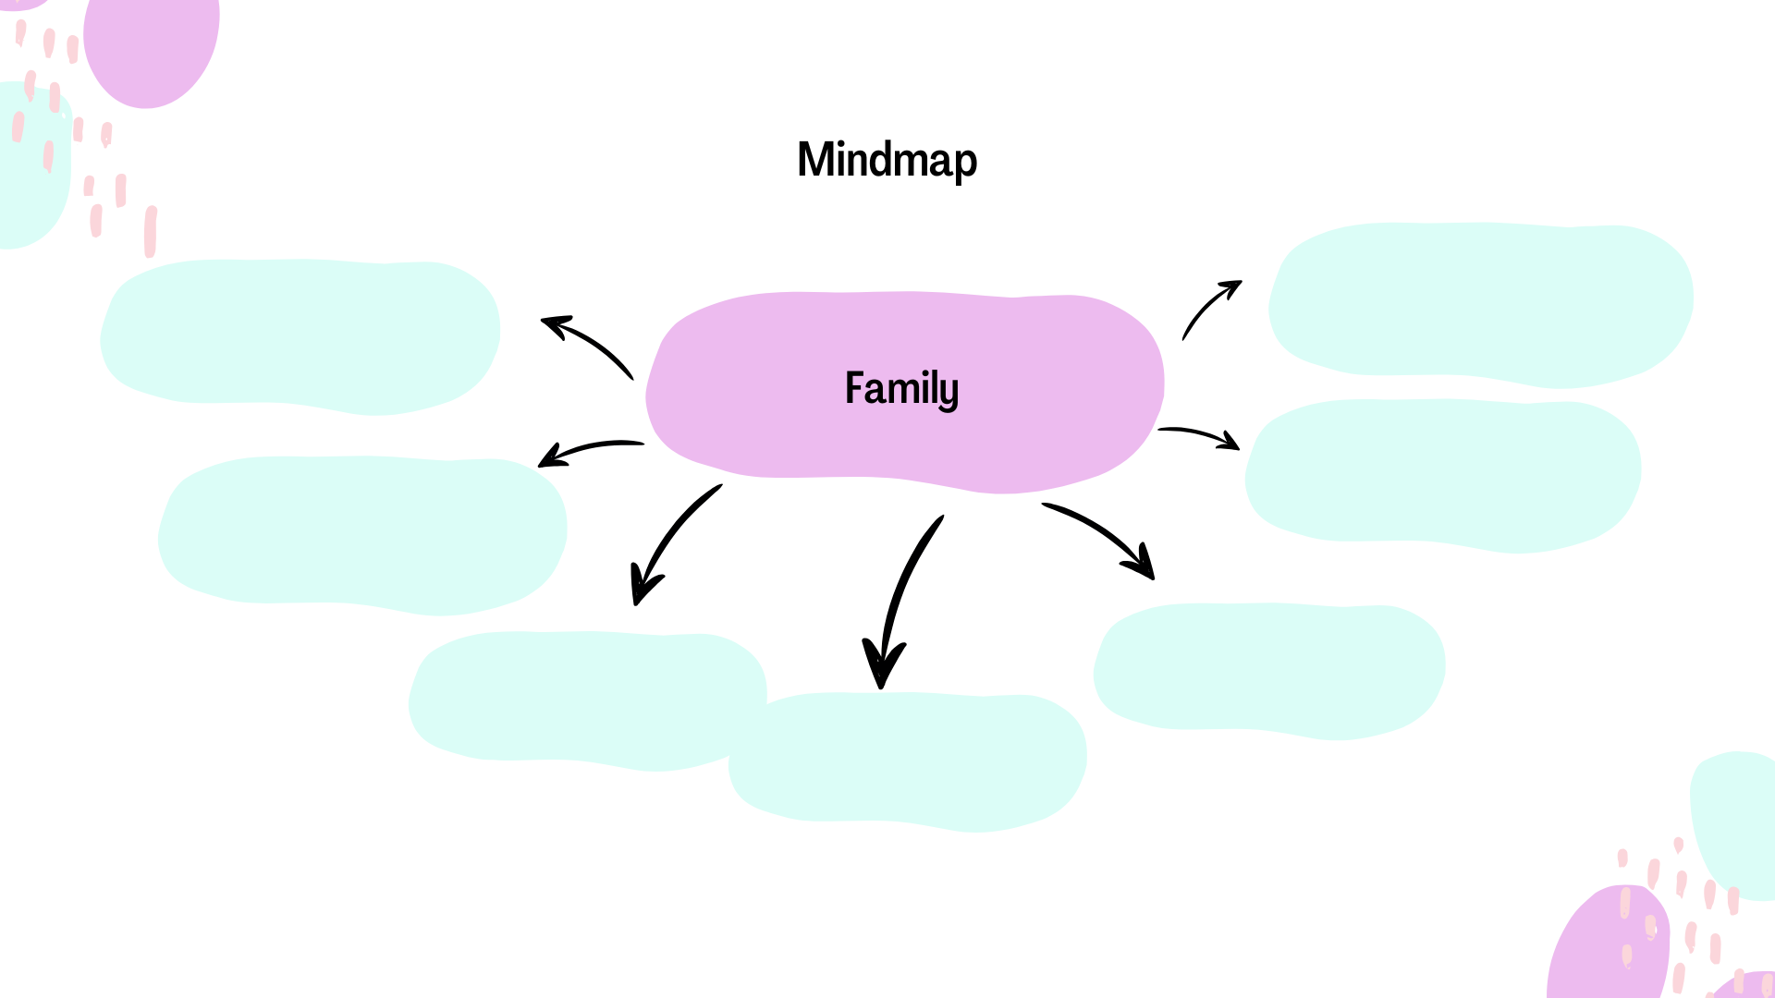

Click or tap here to enter text.

Click or tap here to enter text.

Click or tap here to enter text.

Click or tap here to enter text.

Click or tap here to enter text.

Click or tap here to enter text.

Click or tap here to enter text.

# Phrasal Verbs



Match the phrasal verbs related to family to their definitions in the exercise below. The first one is done for you. Fill in your answers in the boxes below.

| Phrasal Verbs | Definitions |
| --- | --- |
| 1. Get along (with) | A. To stop being friendly after an argument. |
| 2. Look after | B. To start living a stable life. |
| 3. Grow up | C. To resemble a family member. |
| 4. Bring up | D. To raise a child. |
| 5. Fall out (with) | E. To have a good relationship with someone. |
| 6. Make up (with) | F. To take care of someone. |
| 7. Take after | G. To become friends again after an argument. |
| 8. Settle down | H. To become older or an adult. |

|  |  |  |  |  |  |  |  |
| --- | --- | --- | --- | --- | --- | --- | --- |
| 1 | 2 | 3 | 4 | 5 | 6 | 7 | 8 |
| E | _ | _ | _ | _ | _ | _ | _ |

# Gap-Fill Exercise



Complete the sentences using the correct form of the phrasal verbs from the exercise above.

1. My sister and I used to argue a lot, but we always ________ quickly.
2. After their big argument, it took months for them to ________.
3. She definitely ________ her mother—they both love gardening   
   and baking.
4. When I was a child, my grandparents used to ________ me while my parents were at work.
5. Now that he’s 30, he wants to ________, get married, and start   
   a family.
6. My parents ________ me to be independent and hardworking.
7. We had such a fun trip together! It’s clear that we all ________   
   very well.
8. I ________ in a small town, but I moved to the city for university.

# Think about it



1. Who do you get along with in your family?
2. Who do you take after?
3. Does anyone in your family take after you?
4. How do you usually make up with someone after you have had   
   an argument?

# The Law



The law is one of the many themes in this book.

Complete the mind map below with words you associate with law.

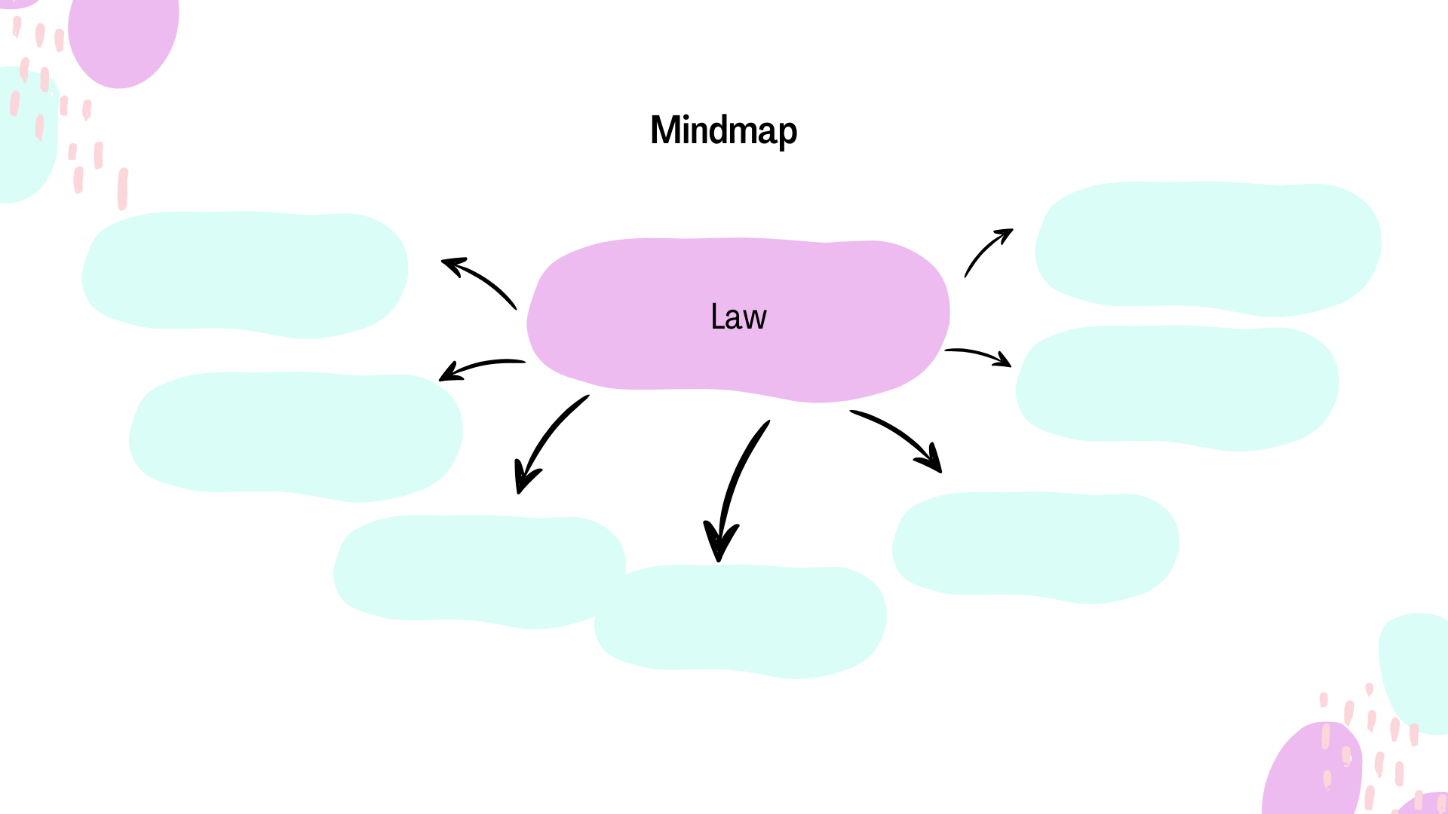

Click or tap here to enter text.

Click or tap here to enter text.

Click or tap here to enter text.

Click or tap here to enter text.

Click or tap here to enter text.

Click or tap here to enter text.

Click or tap here to enter text.

# Writing Practice



Imagine you are Fiona. Today’s court case is about a 14 year old boy who stole his neighbour’s car. The boy’s solicitor is claiming that the boy did not understand what he was doing and he was imitating what he had seen in a video game. Do you think the boy is guilty of car theft? If so, what would his punishment be?

If you think he is innocent of car theft, why do you think this?

Click or tap here to enter text.

# Exploratory Questions



1. Fiona’s difficult relationship with her husband is present throughout this book. What do you think they both could have done differently to repair their relationship sooner?
2. Do you agree with Fiona’s decision to let the hospital treat Adam? Why/ Why not?
3. Religion is a very important theme in this book. Research a religion that you do not know much about and write a little   
   about it.
4. The Henrys have a difficult relationship with Adam after he recovers from his transfusion. There are many famous family conflicts in history. Research a famous family conflict and write about it.
5. Why do you think Adam refused to have treatment in the end?
6. Imagine Adam had survived. What do you think would have happened to him? What do you think his profession would be?
7. If you were to change a part of this story, what would it be?

# Answer Key

Grammar - Present Simple Text

Hidden examples of present simple in the text:

1. Routines: They wake up early, take the Tube to work...
2. Permanent situations: It attracts millions of tourists...
3. Future scheduled events: Tomorrow, the clock tower opens for public tours at 10 a.m.
4. General truths and facts: The River Thames flows through the city...
5. General abilities: They speak dozens of different languages...
6. Feelings: They feel proud of its history...

Past Simple Text

Hidden examples of past simple in the text:

1. Single completed action in the past: "Last Sunday, my family and I spent the entire day by the sea."
2. Repeated actions in the past that don’t happen now: "We used to visit this beach every summer."
3. Past states: "The beach was just as beautiful as I remembered.

Past Continuous Text

Hidden examples of past continuous in the text:

1. Actions in progress at a point in the past: "The courtroom was buzzing with anticipation as the lawyer was presenting her final arguments."
2. Temporary situations in the past: "The trial was stretching into its third week."
3. Annoying past habits: "The defence attorney was always interrupting the prosecution’s arguments."
4. Arrangements and plans for the future in the past: "Earlier in the week, the attorneys were planning to meet for a pre-trial discussion."
5. Actions in progress over a period of time: "The case itself was drawing on every piece of evidence presented."
6. Two actions in progress at the same time: "As the lawyer was speaking, the courtroom stenographer was typing frantically."
7. Background information in a story: "Outside, rain was falling steadily, and the sound was echoing faintly through the grand windows."

Crossword

Across: 3 affair, 6, violin, 7 judgement, 8 leukemia, 9 judge

Down: 1 court stenographer, 2 Jack, 4 whiskey, 5 Melaine, 8 London

Wordsearch

|  |  |  |  |  |  |  |  |  |  |  |  |  |  |  |  |  |  |
| --- | --- | --- | --- | --- | --- | --- | --- | --- | --- | --- | --- | --- | --- | --- | --- | --- | --- |
| f | m | c | o | k | i | f | x | c | j | n | h | a | s | i | g | z | t |
| p | a | e | q | o | d | s | b | v | m | h | i | e | t | z | w | b | n |
| j | p | m | d | p | x | l | q | i | x | d | o | g | n | o | i | m | q |
| g | o | w | i | i | q | x | l | q | r | m | l | s | y | r | u | p | o |
| c | e | k | a | l | c | r | t | o | l | m | c | o | p | e | y | h | f |
| c | t | l | l | d | y | a | s | d | s | m | i | a | n | i | x | c | i |
| o | r | k | r | x | r | e | l | i | g | i | o | n | d | d | t | c | j |
| u | y | l | i | h | v | z | i | j | l | a | t | f | g | a | o | a | j |
| r | u | a | f | f | a | i | r | y | p | m | p | f | l | h | m | n | l |
| t | f | j | u | d | g | e | m | e | n | t | h | o | a | a | a | q | l |
| x | o | y | l | b | j | z | f | i | o | n | a | t | k | j | u | m | k |
| n | w | g | b | w | r | v | d | u | i | e | k | n | v | c | f | a | k |

Phrasal Verbs -Matching Exercise

1. Get along (with) – E
2. Look after – F
3. Grow up – H
4. Bring up – D
5. Fall out (with) – A
6. Make up (with) – G
7. Take after – C
8. Settle down – B

Gap-Fill Exercise

1. Make up
2. Get along
3. Take after
4. Look after
5. Settle down
6. Brought up
7. Get along
8. Grew up