*Brooklyn*

Workbook

Contents

Foreword and Acknowledgements 4

Introductory Questions (before you read) 5

After You Read - Present Simple Tense 6

Reading practice 8

Writing practice 10

Past Simple Tense 11

Reading practice 12

Writing practice 13

Past Continuous Tense 15

Reading practice 15

Writing practice 17

Comparative Adjectives 18

Complete the sentences 19

Identify the Rule 19

Writing Practice 20

Vocabulary 21

Crossword 23

Wordsearch 24

Vocabulary - Family 25

Think about it 26

Vocabulary - Travel 27

Writing Practice 28

Exploratory Questions 29

Answer Key 30

Foreword

This workbook aims to supports adults to improve their English language skills. It covers reading, writing, grammar and comprehension. Each activity has an icon at the top to let you know what is being covered.

**Writing Reading Grammar Comprehension**



# *Brooklyn* was written by Colm Tóibín. This workbook accompanies an adaptation of the original story retold by Kate Williams and illustrated by Matt Rota. This adaptation was written especially for people who are learning English as an additional language.

# The adaptation is a Penguin Level 5 Reader which is B1 in the CEFR framework. Sets of the book are available at Donegal County Library branches. We invite groups to set up book clubs and use this workbook to further develop their literacy skills.

# Acknowledgements

This workbook was written by Emer Tynan, and edited by Joseph Kelly, Donegal County Library Service and Adele McElhinney, Donegal ETB.   
The Adult Literacy for Life National Programme Office, based in SOLAS, funded this project.

# Introductory Questions (before you read)



1. There is a movie based on this book, Brooklyn.   
   Have you watched it? What do you know about the story?

Click or tap here to enter text.

1. Write three things you think might happen in this story.

Click or tap here to enter text.

1. 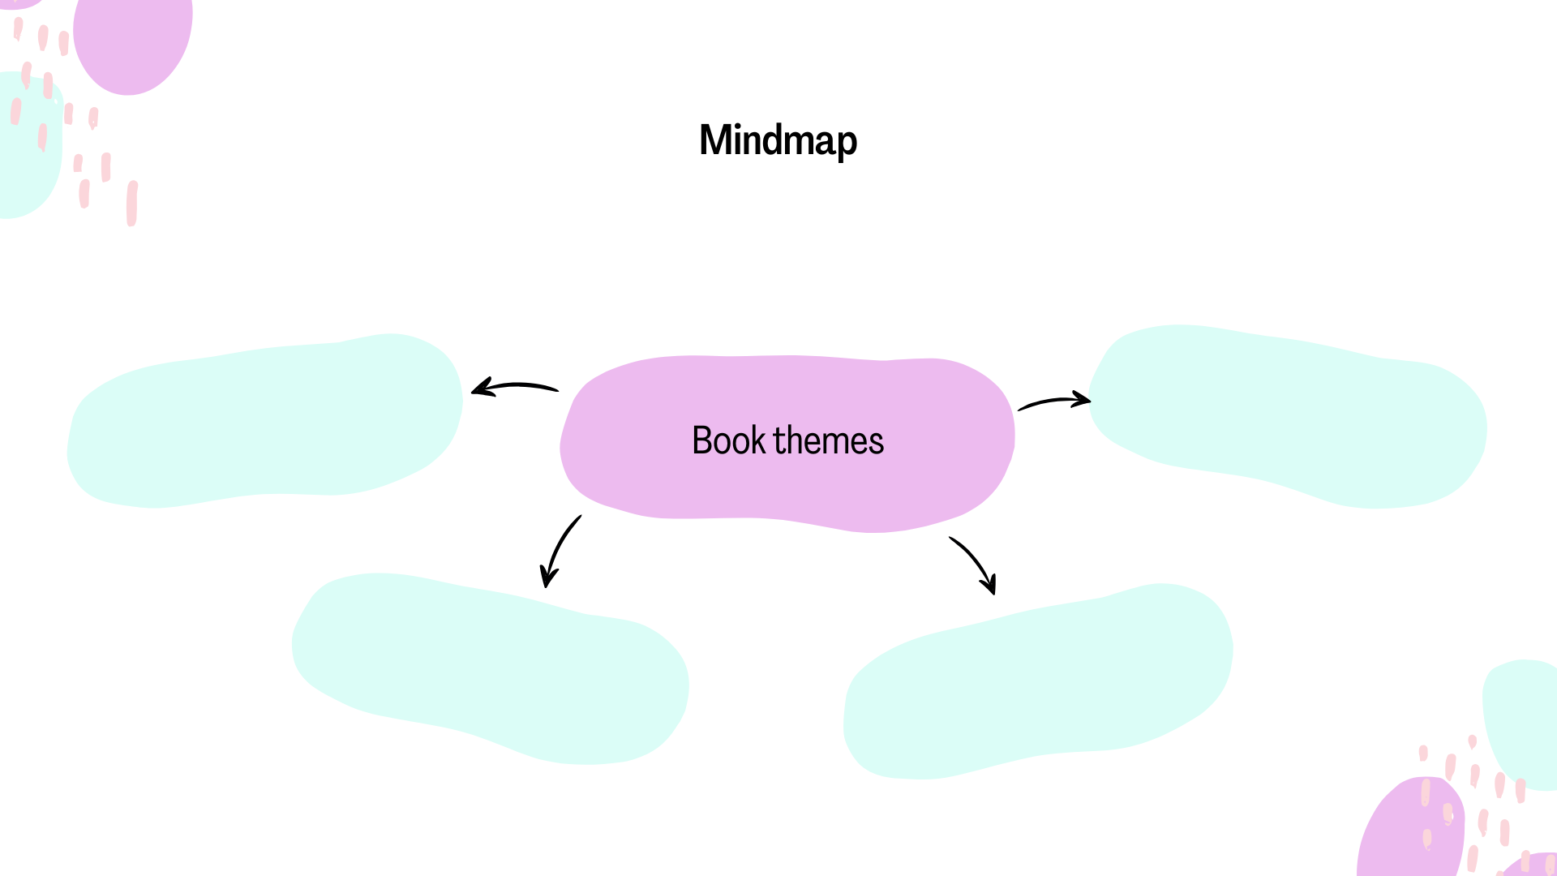A theme of a story is an important message in the story. What do you think the themes of this story might be? Fill in the mind map below with your ideas.

Click or tap here to enter text.

Click or tap here to enter text.

Click or tap here to enter text.

Click or tap here to enter text.

1. A large part of this story **is set** in America. This means that it happens in America. Have you ever visited America?   
   If not, would you like to? Why/Why not?

Click or tap here to enter text.

# After You Read - Present Simple Tense



**Verb: To Be Verb: To Work**

|  |  |
| --- | --- |
| **Subject** | **Conjugation** |
| I | work |
| You | work |
| He/She/It | works |
| We | work |
| You (plural) | work |
| They | work |

|  |  |
| --- | --- |
| **Subject** | **Conjugation** |
| I | am |
| You | are |
| He/She/It | is |
| We | are |
| You (plural) | are |
| They | are |

**Note**

For **regular verbs** like "to work," we add **-s** or **-es** only for the **third person singular** (he/she/it).

We use the Present Simple for the following situations:

1. To talk about routines.

Example: I get up every day at 6am.

1. To talk about permanent situations.

Example: I live in Barcelona.

1. To talk about future scheduled events (according to a timetable).

Example: The bus leaves at 10.40am.

1. To talk about general truths and facts.

Example: Water boils at 100 degrees Celsius.

1. To talk about general abilities.

Example: I play the piano

1. To talk about feelings.

Example: I feel happy today

Example Sentence Practice



Try to write your own example sentences for each of the rules above.

To talk about routines.

Click or tap here to enter text.

To talk about permanent situations.

Click or tap here to enter text.

To talk about future scheduled events (according to a timetable).

Click or tap here to enter text.

To talk about general truths and facts.

Click or tap here to enter text.

To talk about general abilities.

Click or tap here to enter text.

To talk about feelings.

Click or tap here to enter text.

# Reading practice



Read the following text and find an example of each rule in the text.

New York City is a place that never sleeps. Every morning, people rush to work, and the streets fill with taxis, buses, and people walking to their destinations. Many New Yorkers have a routine: they grab a coffee from a corner shop, walk to the subway station, and start their busy day.

New York has tall skyscrapers, famous landmarks, and beautiful parks that make it a unique place. It is also one of the most diverse cities in the world, where you can hear many different languages. This never changes; it’s a city full of life and variety all year round.

Every day, visitors from all over the world come to see famous places like the Statue of Liberty, Times Square, and Central Park. The Statue of Liberty ferry leaves every 30 minutes, so people can easily plan their day around this schedule.

One special fact about New York is that it’s known as "The Big Apple." People call it this because it’s a city full of opportunities. It’s also a cultural centre, with many museums, theatres, and music venues. New York offers something for everyone.

Most New Yorkers know how to get around quickly. They are very good at using the subway and know the best routes to avoid crowds. Walking fast and avoiding tourists is a common skill for locals!

People say they feel both excitement and stress in New York. It’s a city that gives people energy, but it can also make them feel a bit overwhelmed. However, for most people, life in New York feels special and unforgettable.

To talk about routines.



Click or tap here to enter text.

To talk about permanent situations.

Click or tap here to enter text.

To talk about future scheduled events (according to a timetable).

Click or tap here to enter text.

To talk about general truths and facts.

Click or tap here to enter text.

To talk about general abilities.

Click or tap here to enter text.

To talk about feelings.

Click or tap here to enter text.

# Writing practice



Imagine you are Eilis. Write a letter to your mother and Rose about your new routine in Brooklyn.

Click or tap here to enter text.

# Past Simple Tense



Verb: To be (irregular verb) Verb: To work (regular verb)

|  |  |  |  |  |  |  |  |  |  |  |  |  |  |  |  |
| --- | --- | --- | --- | --- | --- | --- | --- | --- | --- | --- | --- | --- | --- | --- | --- |
| |  |  | | --- | --- | | **Subject** | **Conjugation** | | I | was | | You | were | | He/She/It | was | | We | were | | You (plural) | were | | They | were | |  |

|  |  |
| --- | --- |
| **Subject** | **Conjugation** |
| I | worked |
| You | worked |
| He/She/It | worked |
| We | worked |
| You (plural) | worked |
| They | worked |

**Note**

**Regular** verbs like "**to work"** form the past simple by adding **-ed** to the base form. Several verbs form their past tense in an irregular way.

We use the past simple to:

1. Talk about single completed actions in the past.

Example: I washed the dishes after dinner.

1. Talk about repeated actions in the past that don’t happen now.

Example: My father walked to school every day when he young.

1. Past states.

Example: I knew her when we were in school.

Example Sentence Practice

Write your own example sentences for each of the rules above.

Talk about single completed actions in the past.

Click or tap here to enter text.

Talk about repeated actions in the past that don’t happen now.

Click or tap here to enter text.

Past states.

Click or tap here to enter text.

# Reading practice



Read the following text and find an example of each rule in the text.

Last year, I visited Ireland with a group of friends, and it was an unforgettable trip. We explored Dublin, visited famous landmarks, and learned a lot about Irish history and culture. We spent one whole day at Trinity College, where we saw the beautiful library and the famous *Book of Kells*. It amazed us with its detailed artwork.

During our stay, we often took long walks along the cliffs and enjoyed the fresh sea air. We discovered many old castles along the way and imagined what life was like in Ireland hundreds of years ago. Every morning, we had a traditional Irish breakfast at the local pub. They served eggs, sausages, and even black pudding! It became our daily routine for that trip, but we don’t have those kinds of breakfasts at home.

Ireland was a very peaceful and friendly place. People there were always ready to chat with us, and they loved to share stories about their towns. We felt so welcomed everywhere we went. Back then, Ireland seemed like a magical land, full of green hills and friendly people.

Talk about single completed actions in the past.

Click or tap here to enter text.

Talk about repeated actions in the past that don’t happen now.

Click or tap here to enter text.

Past states.

Click or tap here to enter text.

# Writing practice



Imagine you are Eilis. Write a letter to Tony telling him what happened on your journey back to Ireland and what you did last week.

Click or tap here to enter text.

# Past Continuous Tense



We use the past continuous to talk about :

1. Actions in progress at a point in the past.

Example: I was walking my dog at 7am this morning.

2. Temporary situations in the past.

Example: I was staying in a friend’s house until my apartment was ready.

3. Annoying past habits (usually used with always).

Example: My sister was always borrowing my clothes without asking when we were teenagers.

1. Arrangements and plans for the future in the past.

Example: I was excited because I was meeting my sister for lunch later that day.

We also use the past continuous to talk about:

5. Actions in progress over a period of time

Example: I was walking my dog all morning.

6. Two actions in progress at the same time

Example: I was talking to my sister on the phone while I was walking my dog.

7. Background information in a story

Example: The sun was shining and birds were singing. Suddenly, I heard a big crash!

The past simple and the past continuous are often used together to show that one action happened (past simple) to interrupt another action (past continuous).

Example: I was washing the dishes when the phone rang.

# Reading practice



Read the following text and find an example of each rule in   
the text.

It was 1952. Mary was traveling from Ireland to New York by boat, hoping to start a new life in America. While the ship was moving steadily through the rough waves, Mary was sitting on the deck, looking at the ocean around her. She was feeling nervous but excited, thinking about her new life and the job her brother had arranged for her in New York.

During the trip, some passengers were always talking loudly or singing songs, which could be quite annoying when she wanted to rest. As the boat was crossing the Atlantic, Mary walked around the big ship wondering about the lives of the other passengers. She met many other people who were also looking for a fresh start. Many were sharing stories or eating together, trying to make the journey feel shorter. At night, while Mary was watching the stars, she dreamt about the city that she would soon call home, imagining how different life would be there.

Actions in progress at a point in the past.



Click or tap here to enter text.

Temporary situations in the past.

Click or tap here to enter text.

Annoying past habits (usually used with always).

Click or tap here to enter text.

Arrangements and plans for the future in the past.

Click or tap here to enter text.

Actions in progress over a period of time.

Click or tap here to enter text.

Two actions in progress at the same time.

Click or tap here to enter text.

Background information in a story.

Click or tap here to enter text.

# Writing practice



You are Tony. Write a journal entry describing the night you met Eilis. Include the following:   
What you did before going to the dance that evening.

What you were doing when you first saw her.

What she looked like, what you were both wearing and your first impression of her.

Use at least 3 examples of the past continuous and past simple.

Click or tap here to enter text.

# Comparative Adjectives



An adjective is a describing word. It gives more information   
about a noun.

Example: There is a **big** car outside.

Big is the adjective. It describes the car.

Comparative adjectives are used to compare two people, things, or ideas. Here are the main rules for forming them:

1. For most one-syllable adjectives**,** add **"-er"** to the end.

Example: tall → taller, fast → faster

1. For adjectives ending in "e," just add **"-r."**

Example: large → larger, nice → nicer

1. For one-syllable adjectives ending in a single vowel + consonant**,** double the final consonant and add **"-er."**

Example: big → bigger, hot → hotter

1. For most adjectives with two or more syllables**,** use **"**more**"** before the adjective.

Example: beautiful → more beautiful, expensive → moreexpensive

1. For two-syllable adjectives ending in "y," change the "y" to "i" and add **"-er."**

Example: happy → happier, funny → funnier

1. Some adjectives are irregular and have special comparative forms.

Example: good → better, bad → worse, far → farther/further

# Complete the sentences



Complete each sentence using the correct form of the   
word in brackets.

1. My new phone is Click or tap here to enter text. (fast) than my old one.
2. This math problem is Click or tap here to enter text. (easy) than the last one.
3. Walking is Click or tap here to enter text. (healthy) than driving   
   short distances.
4. Alaska is Click or tap here to enter text. (far) north than Canada.
5. In spring, days are Click or tap here to enter text. (long) than in winter.

# Identify the Rule



Write the rule number (1-6) next to each adjective to show which rule was applied.

|  |  |
| --- | --- |
| **Sentence** | **Adjective rule number** |
| 1. My new phone is faster than my old one. | Click or tap here to enter text. |
| 1. This math problem is easier than the last one. | Click or tap here to enter text. |
| 1. Walking is healthier than driving short distances. | Click or tap here to enter text. |
| 1. Alaska is farther north than Canada. | Click or tap here to enter text. |
| 1. In spring, days are longer than in winter. | Click or tap here to enter text. |

# Writing Practice



Write a short paragraph comparing your country to where you   
live now. Think about population, climate, culture and local amenities.

Click or tap here to enter text.

# Vocabulary



The characters

1. Who is your favourite character in the story? Why?

Click or tap here to enter text.

1. An adjective is a describing word. It gives more information about a noun.

Example: There is a **big** car outside.

Big is the adjective. It describes the car.

Some examples of adjectives of personality are: friendly, happy, brave and kind.

Use 3 adjectives of personality to describe each of the characters below:

Eilis Click or tap here to enter text.

Rose Click or tap here to enter text.

Tony Click or tap here to enter text.

Jim Click or tap here to enter text.

Mrs Lacey Click or tap here to enter text.

Father Flood Click or tap here to enter text.

Miss Kelly Click or tap here to enter text.



1. Imagine you are the writer, Colm Tóibín. You are going to add a new character to the story.

Who are they connected to? What 3 adjectives of personality would you use to describe them? How would the story be different if they were in it?

Click or tap here to enter text.

1. How did you feel about Eilis at the beginning of the story?

How did you feel about her at the end?

Click or tap here to enter text.

# Crossword



Print this page to complete the crossword below using the clues given,

or you can complete this [crossword online](https://tinyurl.com/25jrooqv).

# Wordsearch



Print this page and find all the hidden words associated with the story in the wordsearch below. Or you can also play this [wordsearch online](https://thewordsearch.com/puzzle/8127497/brooklyn/#google_vignette).

Words are hidden in all directions.

Italian Brooklyn Enniscorthy Irish

York secret new Bartoccis

marriage bookkeeper dodgers Manhattan

|  |  |  |  |  |  |  |  |  |  |  |  |  |  |  |
| --- | --- | --- | --- | --- | --- | --- | --- | --- | --- | --- | --- | --- | --- | --- |
| y | r | j | n | n | t | q | y | f | s | w | e | m | o | i |
| j | j | q | u | c | f | v | m | x | l | v | m | w | c | a |
| e | g | a | i | r | r | a | m | w | m | j | d | m | r | w |
| t | a | v | o | h | w | u | e | k | x | w | o | q | t | l |
| a | d | s | y | r | e | p | e | e | k | k | o | o | b | n |
| e | n | n | i | s | c | o | r | t | h | y | h | q | f | a |
| v | m | j | d | s | e | c | r | e | t | y | s | c | p | i |
| j | d | q | b | t | w | x | r | l | i | h | i | f | q | l |
| w | f | m | a | n | h | a | t | t | a | n | r | d | a | a |
| e | j | f | w | h | z | k | x | l | s | p | i | u | a | t |
| n | u | k | d | x | s | i | c | c | o | t | r | a | b | i |
| c | u | m | g | j | g | h | a | b | x | g | w | u | b | a |
| c | d | k | d | u | k | r | y | p | k | r | o | y | s | t |
| b | r | o | o | k | l | y | n | h | x | v | l | w | z | c |
| k | o | o | a | g | y | d | o | d | g | e | r | s | i | b |

# Vocabulary - Family



Eilis’ relationship with her family is very important to her. At the beginning of the book, her father has passed away but she still has her mother and 4 siblings; 3 brothers and 1 sister.

Test yourself

Write 8 words related to family in the spaces below:  
Click or tap here to enter text.

Click or tap here to enter text.

Click or tap here to enter text.

Click or tap here to enter text.

Click or tap here to enter text.

Click or tap here to enter text.

Click or tap here to enter text.

Click or tap here to enter text.

# Think about it



Love and relationships is a very prominent theme in this book.

What words do you associate with love?

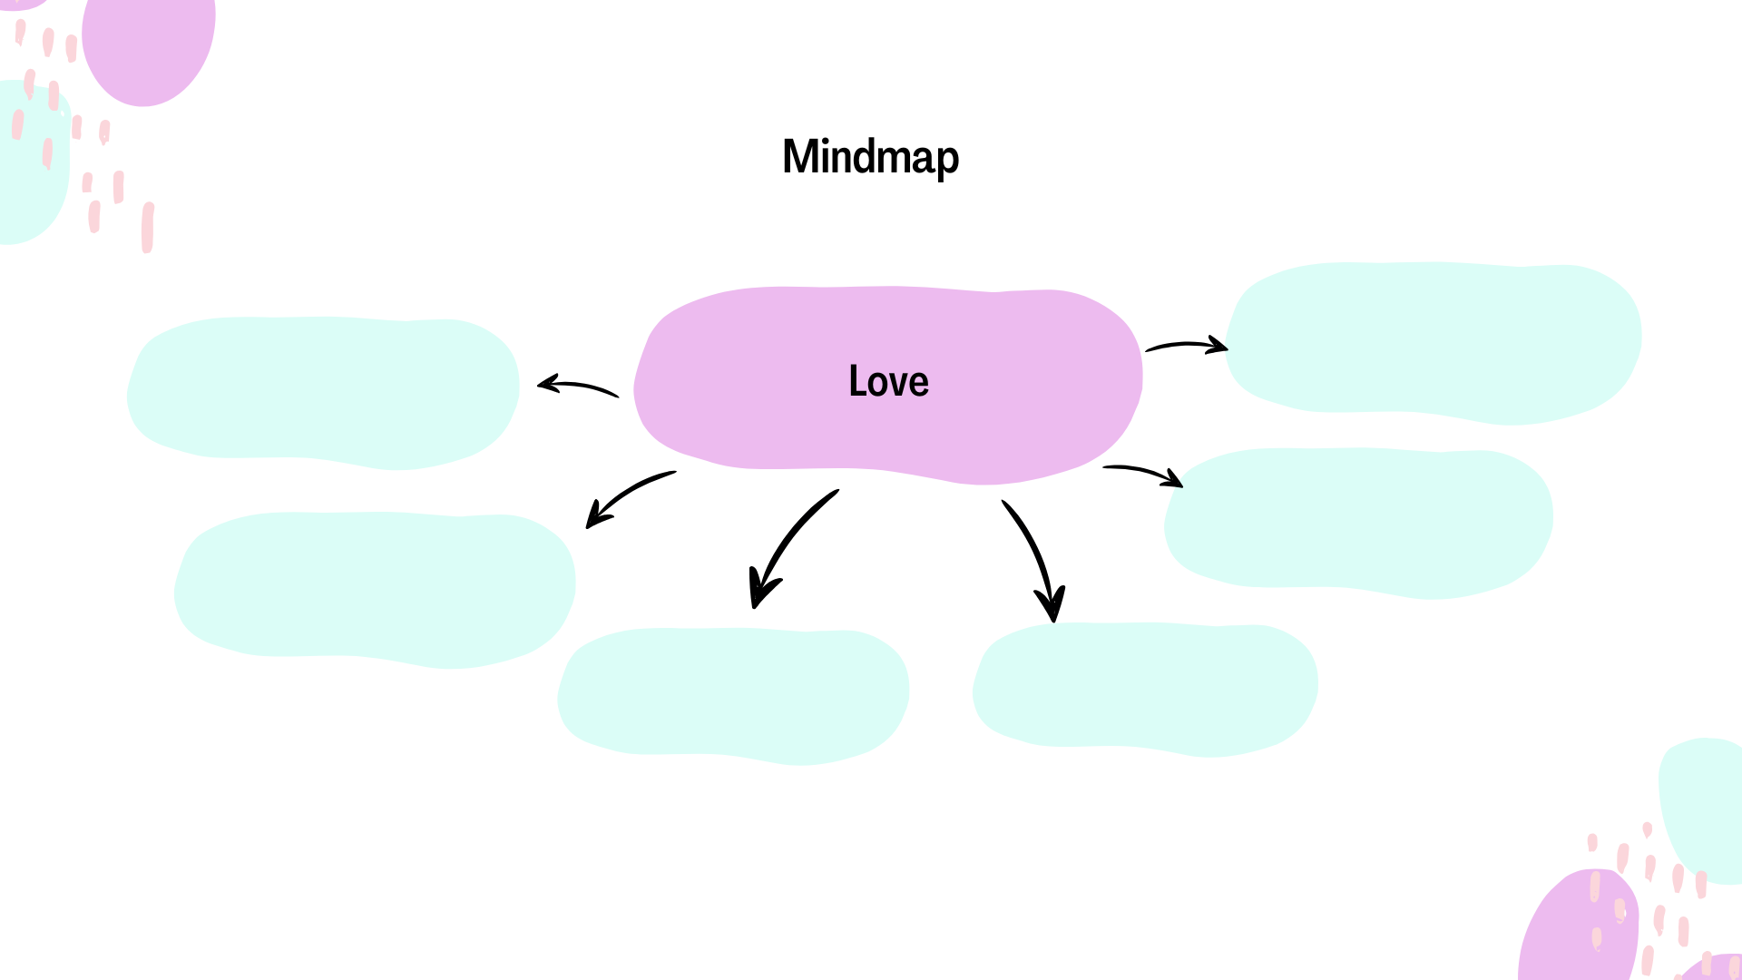Complete the mind map below with your ideas.

Click or tap here to enter text.

Click or tap here to enter text.

Click or tap here to enter text.

Click or tap here to enter text.

Click or tap here to enter text.

Click or tap here to enter text.

Eilis becomes involved in a *love triangle* in the story. A love triangle is when one person is in love with 2 other people and has to choose one of them to continue a relationship with.

1. Why do you think she cared for Jim? What characteristics do you think she liked about him?

Click or tap here to enter text.

1. Why do you think she returned to Tony? What did she love about him?

Click or tap here to enter text.

# Vocabulary - Travel



Travel is one of the many themes in this book.

Complete the mind map below with words you associate with travel.

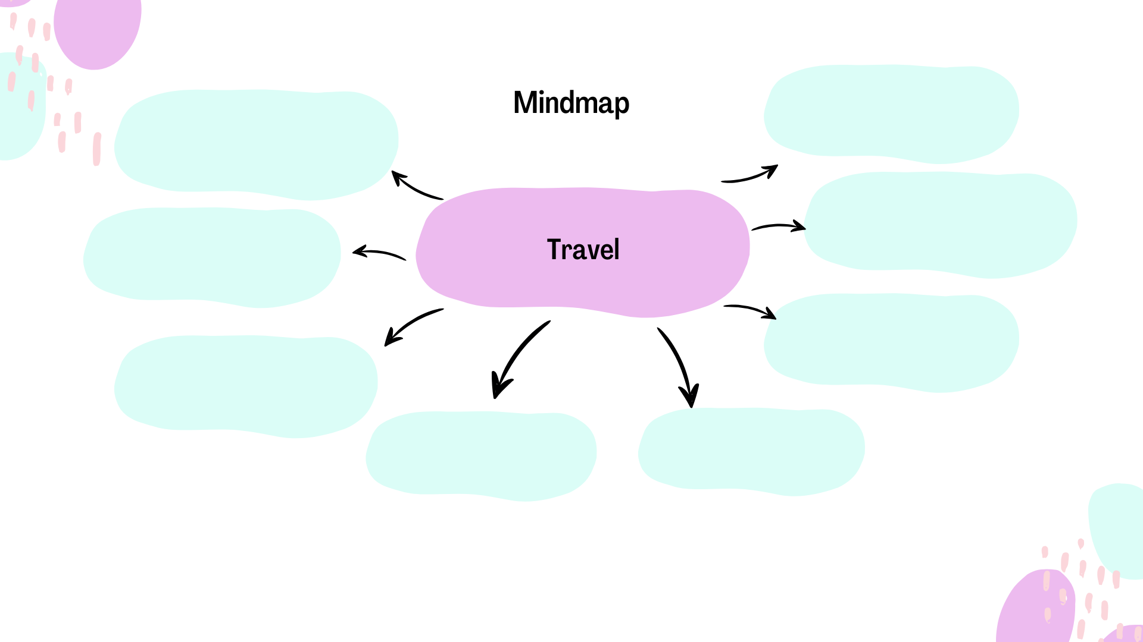

Click or tap here to enter text.

Click or tap here to enter text.

Click or tap here to enter text.

Click or tap here to enter text.

Click or tap here to enter text.

Click or tap here to enter text.

Click or tap here to enter text.

Click or tap here to enter text.

# Writing Practice



Imagine you are on a beautiful cruise ship. You are travelling around the Mediterranean Sea. Look around. Who is travelling with you on the ship? Do you know them? What do they look like? Are you happy to be on this adventure with them?

Think about the views, the colours of the sea, the smells and the sounds along the way.

Write about how you are feeling on this journey.

Click or tap here to enter text.

# Exploratory Questions



1. Why do you think Rose arranged for Eilis to go to Brooklyn?
2. Do you think Eilis is happy with her decision to return to Brooklyn? Is she happy in her life?
3. What do you think will happen to Eilis in the future? Do you think she will remain married to Tony? Why/ Why not?
4. What do you think will happen to Eilis’ mother? What will her life be like in Enniscorthy on her own?
5. Who did you want Eilis to choose- Jim or Tony? Why?
6. Imagine Rose has not died. How do you think Eilis’ life would have been different?
7. If you were to change a part of this story, what would it be?

# Answer Key

Grammar - Present Simple Text

Hidden examples of present simple in the text:

1. To talk about routines: "Many New Yorkers have a routine: they grab a coffee from a corner shop..."
2. To talk about permanent situations: "New York has tall skyscrapers, famous landmarks, and beautiful parks..."
3. To talk about future scheduled events: "The Statue of Liberty ferry leaves every 30 minutes..."
4. To talk about general truths and facts: "One special fact about New York is that it’s known as 'The Big Apple.'"
5. To talk about general abilities: "Most New Yorkers know how to get around quickly."
6. To talk about feelings: "People say they feel both excitement and stress in New York."

Past Simple Text

Hidden examples of past simple in the text:

1. Single completed actions in the past: "Last year, I visited Ireland with a group of friends..."
2. Repeated actions in the past that don’t happen now: "Every morning, we had a traditional Irish breakfast at the local pub."
3. Past states: "Ireland was a very peaceful and friendly place.

Past Continuous Text

Hidden examples of past continuous in the text:

1. Actions in progress at a point in the past: "Mary was traveling from Ireland to New York by boat..."
2. Temporary situations in the past: "Mary was sitting on the deck, looking at the ocean around her."
3. Annoying past habits (usually used with 'always'): "Some passengers were always talking loudly or singing songs..."
4. Arrangements and plans for the future in the past"...the job her brother had arranged for her in New York."
5. Actions in progress over a period of time: "As the boat was crossing the Atlantic…Mary was wondering..."
6. Two actions in progress at the same time: "While Mary was watching the stars, she dreamt about the city..."
7. Background information in a story: "In the 1950s, Mary was traveling from Ireland to New York by boat, hoping to start a new life..."

Comparative Adjectives

Part 2: Complete the Sentences

1. My new phone is **faster** (fast) than my old one.
2. This math problem is **easier (**easy) than the last one.
3. Walking is **healthier** (healthy) than driving short distances.
4. Alaska is **farther** (far) north than Canada.
5. In spring, days are **longer (**long) than in winter.

Identify the Rule

| **Sentence** | **Rule #** |
| --- | --- |
| 1. My new phone is faster than my old one. | 1 |
| 1. This math problem is easier than the last one. | 5 |
| 1. Walking is healthier than driving short distances. | 5 |
| 1. Alaska is farther north than Canada. | 6 |
| 1. In spring, days are longer than in winter. | 1 |

**Crossword**

Across: 5 seasick, 6 emigrate, 8 Bartoccis, 10 Enniscorthy

Down: 1 love triangle, 2 lodger, 3 plumber, 4 dilemma, 7 homesick, 9 grief

**Wordsearch**

|  |  |  |  |  |  |  |  |  |  |  |  |  |  |  |
| --- | --- | --- | --- | --- | --- | --- | --- | --- | --- | --- | --- | --- | --- | --- |
| y | r | j | n | n | t | q | y | f | s | w | e | m | o | i |
| j | j | q | u | c | f | v | m | x | l | v | m | w | c | a |
| e | g | a | i | r | r | a | m | w | m | j | d | m | r | w |
| t | a | v | o | h | w | u | e | k | x | w | o | q | t | l |
| a | d | s | y | r | e | p | e | e | k | k | o | o | b | n |
| e | n | n | i | s | c | o | r | t | h | y | h | q | f | a |
| v | m | j | d | s | e | c | r | e | t | y | s | c | p | i |
| j | d | q | b | t | w | x | r | l | i | h | i | f | q | l |
| w | f | m | a | n | h | a | t | t | a | n | r | d | a | a |
| e | j | f | w | h | z | k | x | l | s | p | i | u | a | t |
| n | u | k | d | x | s | i | c | c | o | t | r | a | b | i |
| c | u | m | g | j | g | h | a | b | x | g | w | u | b | a |
| c | d | k | d | u | k | r | y | p | k | r | o | y | s | t |
| b | r | o | o | k | l | y | n | h | x | v | l | w | z | c |
| k | o | o | a | g | y | d | o | d | g | e | r | s | i | b |